

Home Office Biometrics

**UNDERPINNED BY DEPENDABILITY, MOMENTUM   
AND TRUST**

Outline Solution Document

Contents

1 Executive Summary 1

1.1 Introduction 1

1.2 Solution Overview 2

1.3 Architectural Decisions 3

1.3.1 Overall architecture approach 3

1.3.2 Hosting approach for MSB 4

1.3.3 Witness site hosting location 5

1.3.4 Tech refresh approach 5

1.4 System context 6

1.5 Change cases 8

2 Application architecture 9

2.1 Component Model 9

2.1.1 Component Model Overview 9

2.1.2 Component Descriptions 9

2.1.3 Component Change Summaries 12

2.1.4 Stage 1 Change Summary 13

2.1.5 Fingerprint Base Capability Validation - Change Summary 14

2.1.6 Face Base Capability Validation - Change Summary 16

2.1.7 Stage 2 - 5 Rollout - Change Summary 18

2.2 Data Architecture 19

2.2.1 Conceptual Data Model 20

2.3 Data Stores 21

2.3.1 Data Migration and Parallel Run / Cutover Approach 22

2.4 SOA Service Architecture 26

3 Infrastructure architecture 28

3.1 Infrastructure & Platform 28

3.1.1 Location view 28

3.1.2 Operational Model 29

3.1.3 NFRs 33

3.2 Physical Hosting 34

3.3 Environment View 35

3.4 Systems Management software and Supporting Tools 35

3.5 Infrastructure Changes 36

3.5.1 Transition Architecture – Support Sites 36

3.5.2 Transition Architecture – Witness Services 36

3.5.3 Additional Crown Hosting Capacity 36

3.6 Network Architecture 38

3.7 Network Separation 40

3.8 Performance Engineering Modelling Approach 41

3.9 Performance 42

3.9.1 Performance Engineering 42

3.9.2 Performance requirements 43

3.9.3 Performance Model 44

3.10 Capacity 45

3.10.1 Processing capacity 45

3.10.2 Storage capacity 45

3.10.3 Network capacity 45

3.10.4 Capacity provisioning activities 46

3.11 Bandwidth and I/O 46

3.12 Tech Refresh 47

3.12.1 Software Refresh 47

3.12.2 Hardware Refresh 48

Security 51

3.13 Secure ways of working 51

3.14 Privacy 51

3.15 Patching 52

3.16 Removable media handling 52

3.17 Security Event Management / SOC 52

3.18 PKI and Key Management 52

3.19 Authentication & Authorisation 53

3.20 Integrity 53

3.21 Audit (including additional solution) 53

3.22 Non-Standard Services (NSS) 55

4 Service model 56

4.1 IT Service Management Solution 56

4.1.1 IT Systems Management 56

4.1.2 Remote Support 57

4.1.3 Promotion Route to Live 58

4.1.4 Capacity Management 59

4.1.5 Software licence monitoring and management 59

4.2 ITSM and Security Management Tooling 59

4.2.1 Service delivery locations and organisation role structure 59

4.2.2 High level operating manual 60

4.2.3 Crown Hosting Operations 60

4.2.4 Support of high priority services and location 60

References

|  |  |  |
| --- | --- | --- |
| Ref | Document Name | Document Filename |
| 1 | Matcher Service Platform (MSP) - Solution Design) | DR340 BMPS MSP Solution Design - Design Model v2.7.docx |
| 2 | DR110 Matcher Data Audit | DR110 Matcher Data Audit.docx |
| 3 | Primergy Server Support Roadmap | <https://www.fujitsu.com/us/imagesgig5/PRIMERGY-Server%20Support%20Roadmap_EOSL_V4.pdf> |
| 4 | BMPS Security Aspects Letter | DR080 BMPS Security Aspects Letter.docx |
| 5 | BMPS Enterprise Management HLD | DR240-03 BMPS Enterprise Management HLD v6.7.docx – Section 2.1 |
| 6 | BMPS Volumetric Model | Schedule 2.1 Services Description v1.0 FINAL- Annex D – BMPS Volumetric Model |

Glossary

| Term | Definition |
| --- | --- |
| AWS | Amazon Web Services |
| BAT | Biometric Accuracy Test |
| BMPS | Biometric Matcher Platform & Associate Services |
| FBIS | Future Borders and Immigration System Programme |
| HMPO | Her Majesty’s Passport Office |
| HOB | Home Office Biometrics |
| IABS | Immigration Biometric System |
| IDENT1 | Law Enforcement Biometric System |
| ITT | Invitation To Tender |
| MDI | Matcher Deployment Instance |
| MES | Matching Engine Software |
| MSB | Matcher Service Bus |
| MSP | Matcher Service Platform |
| MSS | Matcher Service Supplier |
| NFR | Non-Functional Requirement |
| NSS | Non-Standard Services |
| RHEL | Red Hat Enterprise Linux |
| RUMPUS | Re-Usable Model of the Performance & Utilisation of Systems |
| SCCM | (Microsoft) System Centre Configuration Manager |
| SCOM | (Microsoft) System Centre Operations Manager |
| SCSM | (Microsoft) System Centre Service Manager |
| SIEM | Security Incident and Event Management |
| SOA | Service Oriented Architecture |

# Executive Summary

## Introduction

This document summarises our overall solution approach, demonstrating our understanding of the existing architecture and going into more detail in the areas where change will be required.

We recognise the work undertaken to date to establish the HOB Matcher platform and for delivery of fingerprint functionality. Our over-arching approach is to build on that investment, recognising from the ITT materials that the current solution broadly meets the needs of the fingerprint functionality including promising progress on performance. We believe the focus now needs to be on building upon the existing solution to:

* successfully prove and rollout the fingerprint functionality into live service
* and to build and rollout the face matching functionality

to deliver the envisaged business benefits as swiftly as is practical. Significant architectural or technical changes are likely to add more time into the already challenging schedule and should be considered after stage 5.

Matcher has been on a difficult journey, we recognise this and want to help you change it, we believe in the solution and through the strong partnership of yourselves, IBM, Aware and the MES providers we can make it a success. The solution and plan are structured to achieve the objectives commencing with the transfer of remaining delivery tasks of the Stage 1 IDENT1 solution from the incumbent as part of Service Transition. IBM is deploying a senior experienced team which has Biometrics and Home Office expertise at the start of the programme to assure the delivery. If necessary, IBM will TUPE incumbent staff, but we will inject new HOB experienced resources to step change the programme delivery, these experienced, capable resources help mitigate the exit of the incumbent.

Our senior Red team review will work with you to confirm the current state of the programme and solution and identify the prioritised actions to accelerate the programme. IBM has undertaken a robust planning process which has assessed the plan top down and bottom up to ensure we are confident of delivery. The plan, activities and solution have all been developed and reviewed by a skilled HOB knowledgeable team who understand the business needs, the architecture and the programme ways of working. We will deploy ways of working with the key strategic suppliers in line with our years of successful delivery of IABS. This will involve working in partnership with Idemia on site in Hursley co located with our delivery team.

Following the completion of Service Transition, IBM will commence work on completing the Stage 1 activities, and the delivery of the Face base capability in preparation for the Stage 3-5 rollout.

We will continue to seek ongoing delivery efficiencies as we get more access to the real solution. If we can identify areas to for example introduce greater automation, or particular solution components that are proving to be a ‘drag’ on delivery velocity, we will assess these and present to the Authority (including engagement with governance bodies such as TDA) our view of the potential changes and resulting benefits.

IBM has a structured architectural method – Unified Method Framework 2.0 – which provides overarching work-products that help teams with understanding and establishes traceability between the architectural views. We have drawn upon this method in creating this solution outline, which we believe should be a document which aids all project members in understanding the overall solution to be delivered and providing context to the individual detailed technical work products.

## Solution Overview

Figure 1 introduces the solution at an overview level.

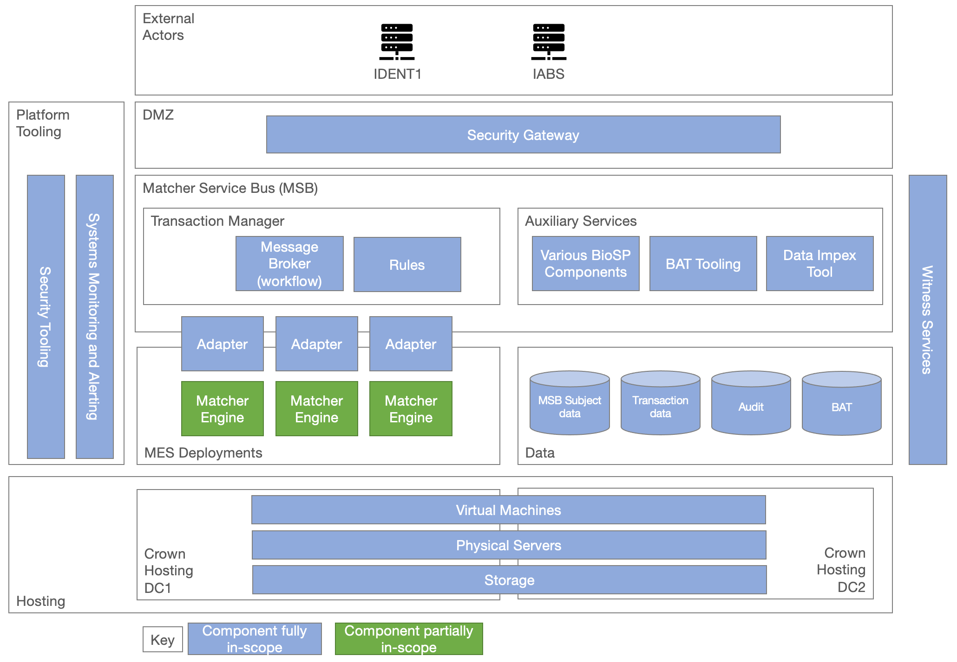

Figure 1 – HOB Matcher Solution Overview

The key aspects of the solution are:

| Concept | Description |
| --- | --- |
| External Actors | Strategically, all processing requests will originate from the HOB Central systems. |
| DMZ | The DMZ and security gateway subsystem provide separation from business and management data zones and provide protection from inbound threats. |
| Matcher Service Bus | Components in this subsystem can grouped as either belonging to the Transaction Manager or Auxiliary Services. Within the Transaction Manager, Message Broker and Rules components provide the workflow services that fulfil incoming requests. The Auxiliary Services include components that support the workflow services, and components that support the operational running of the system. |
| MES Deployments | This subsystem houses the multiple MES deployments. Interaction with the MESs is provided through Matcher Adapters aligned to each MES. The MES software is provided by 3rd party suppliers but hosted and operated by IBM as part of the solution. |
| Data | This subsystem provides the logical data stores required by the solution components. |
| Hosting | The solution is deployed in Crown Hosting data-centres using a mix of physical and virtualised infrastructure, and SAN-based storage. |
| Platform Tooling | Tooling in this area supports system, security and performance monitoring and reporting, as well as providing capabilities for security scanning and remote access. |
| Witness | Witness services are hosted outside of the main solution to provide tie-breaking capability to prevent split-brain cluster scenarios. |

## Architectural Decisions

This section outlines the key architectural decisions we have made in preparing the solution outline and overall response based on our understanding of the solution materials and wider HOB Programme priorities.

These describe our shaping rationale and choices; we are open to discussing these during delivery as there may be influencing factors that we are not currently aware of, or changes to the overall delivery context that arise over time.

This architectural decision record then provides a means to reflect a changed position based on new information, and to then ripple those changes through the overall solution in a controlled manner.

### Overall architecture approach

|  |  |
| --- | --- |
| **ID** | Architecture Decision 1 (AD1) |
| **Subject Area** | Overall solution approach |
| **Decision to be made** | The current matcher solution architecture for stage 1 is based on BioSP MSB as the interface to several matching engines, all of which is hosted on Crown Hosting. A decision is required about whether to continue with this overarching architecture, or if overarching architectural changes are required. |
| **Options considered** | 1. Continue with the existing solution architecture 2. Replace BioSP with an alternative middleware |
| **Resolution** | Option 1 – continue with the existing solution architecture is selected. |
| **Rationale** | Our understanding from the materials presented during the ITT is that the current solution broadly meets the needs of stage 1 including performance, with all the foundations in place[1]. We believe the focus now needs to be on continuing to deliver stages 1-5 into live service to provide the business benefits as swiftly as is practical.  The main areas of architectural change identified for future consideration from our understanding to date are:   * removal of BioSP to significantly reduce ongoing licence costs, which could be investigated after phase 5 about porting to an alternative service bus, although the cost/benefit of this will need close examination * investigation of cloud hosting to gain the benefits of elasticity, and use of cloud-provider managed services e.g. database-as-a-service – this is considered further in AD2. |
| **Implications / Risks** | Continued software maintenance fee for BioSP. |

### Hosting approach for MSB

|  |  |
| --- | --- |
| **ID** | Architecture Decision 2 (AD2) |
| **Subject Area** | Infrastructure |
| **Decision to be made** | The current matcher solution architecture for stage 1 is on-premises hosted on Crown Hosting. A decision is required about whether to continue with this, or whether to move to align with the Home Office and wider Government cloud-first strategy. It is noted that this decision is only for the MSB layer, as the MES’s are understood to not currently be cloud compatible[2]. |
| **Options considered** | 1. Continue with the existing on-premises hosting 2. Migrate BioSP to Home Office strategic cloud (EBSA or LECP) 3. Migrate BioSP to an alternative cloud platform |
| **Resolution** | Option 1 – continue with the existing hosting. |
| **Rationale** | Three main factors influenced this decision:   1. Moving the MSB layer to cloud whilst MES remain on-premises brings little immediate benefits, and increases complexity e.g. latency considerations, distributed solution makes problem diagnosis more difficult, increased skills mix in the delivery/support team. 2. Undertaking migration of a significant layer of the solution to cloud will likely lead to delays to accommodate this alongside delivery of stages 1-5. 3. The current solution has made significant investment in physical hardware in Crown Hosting that should be maximised.   Usage of cloud platforms may provide future benefit e.g. increased ease of deployment automation / increased use of ‘as a service’ components.  In future we will be happy to help investigate the future roadmap for MES cloud compatibility, alongside hardware refresh dates of existing infrastructure. This would inform a future move-to-cloud decision at this point, with a better understanding of potential cost case / ROI for doing so. |
| **Implications** | * Future investigation of cloud migration path aligned with MES cloud support roadmap * In the short to mid-term if cloud platform capabilities are identified and desirable, technology such as AWS Outposts could be investigated to provide these capabilities in an on-premises setting |

### Witness site hosting location

|  |  |
| --- | --- |
| **ID** | Architecture Decision 3 (AD3) |
| **Subject Area** | Infrastructure |
| **Decision to be made** | The witness services to prevent split-brain problem for clusters in certain failure scenarios require a new hosting solution. These are currently hosted in incumbent supplier data-centres which will no longer be available. |
| **Options considered** | 1. Establish new on-premises hosting locations 2. Host witness services on Home Office strategic cloud (EBSA or LECP) 3. Host witness services on an alternative cloud platform |
| **Resolution** | Option 1 – establish new on-premises witness hosting locations – using locations already hosting other secure Home Office services: Kyndryl Portsmouth data centre and IBM Hursley |
| **Rationale** | Option 1 is:   * consistent with the hosting approach and risk profile of the overall solution * provides a straight-forward and low-risk migration path from the existing witness service hosting * complies with the required NFRs for the solution |
| **Implications** | * Co-ordination required for lift and shift of servers from incumbent hosting * Assumption that standard secure lift and shift is appropriate for this infrastructure – no requirement for police escort or similar |

### Tech refresh approach

|  |  |
| --- | --- |
| **ID** | Architecture Decision 4 (AD4) |
| **Subject Area** | Tech Refresh |
| **Decision to be made** | Much of the software / middleware / OS will go out of support during the lifetime of the contract |
| **Options considered** | 1. Ongoing evergreen to keep to latest versions 2. Targeted refreshes to keep on supported versions 3. No refresh – keep to existing versions |
| **Resolution** | Option 2 – targeted refresh to stay on supported versions of software |
| **Rationale** | * Defers most disruption of refresh until after initial stages are delivered and primary business benefits are in place. * ‘Sweat’ existing assets, wherever possible. * Minimise costs, whilst maintaining security compliance. |
| **Implications** | * Ongoing refresh of perimeter / security enforcing hardware in advance of end-of-support dates * Major software refresh after stage 2/3 go live and before remaining stages go-live * Server hardware refresh was agreed during negotiation to be out of scope and to be handled with a change request at the point at which it is agreed necessary, in order for the existing hardware to be ‘sweated’ for as long as is viable.   See section *3.12 - Tech Refresh* for further details |

## System context

The system context is summarised in Figure 2. The system context illustrates the interactions with systems and actors outside of the system boundary, identifying interfaces to be built/tested and user groups that will require access. The system context includes users who interact with supporting systems within the solution (e.g. monitoring/security systems), as well as direct business usage. The solution within the system boundary will be described in the architecture overview / component model etc. in later sections.

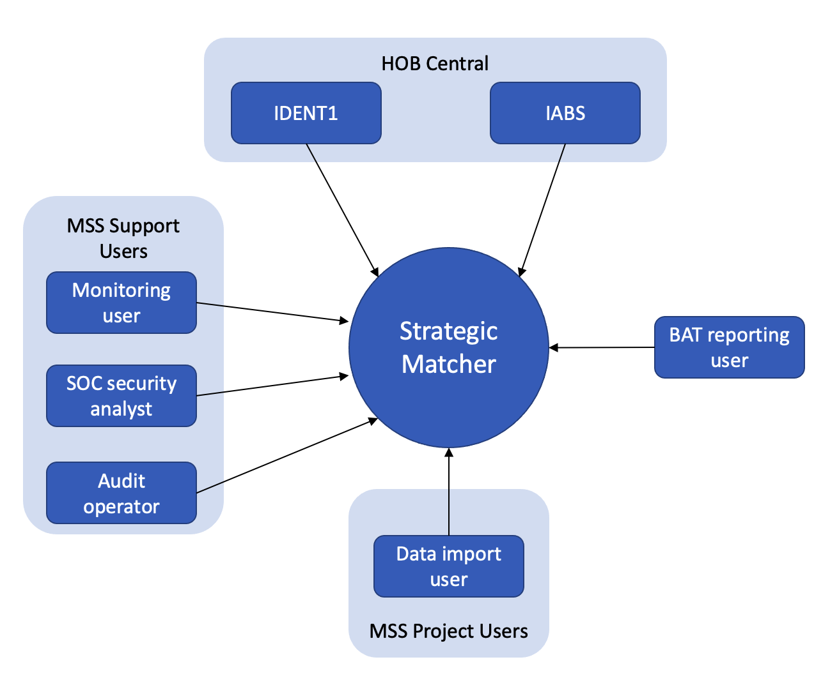

Figure 2 – System Context

|  |  |  |
| --- | --- | --- |
| External Entity | Type | Description |
| HOB Central – IDENT1 | Synchronous / Asynchronous webservice | Existing system used for Law Enforcement biometric matching |
| HOB Central – IABS | Synchronous / Asynchronous webservice | Existing system used for Immigration biometric matching |
| Support – Monitoring User | Interactive usage of system monitoring tools | Access to tooling provided by the programme, to monitor the health of the solution. |
| Support – Security Analyst | Interactive usage of security monitoring tools | Access to tooling provided by the programme, to monitor the security of the solution. |
| Project – Data Import User | Interactive use of data import tools | Access to tooling provided by the programme, to import data from the existing biometric matching systems (IDENT1 and IABS). |
| Audit Operator[3] | Access to audit reports | Access to audit data to run queries/reports as requested by business sources including Security Working Group and police auditors. |
| BAT Reporting User | Access to BAT reports | Access to ongoing biometric accuracy quality checking (‘BAT ping’). |

## Change cases

Change cases provide a means of identifying potential future (but uncommitted) changes to assist with architectural planning. These change cases can be kept in mind during the committed work to avoid taking actions that will make them more difficult to pursue in future.

We have identified a number of potential change cases, for review as part of the longer-term HOB roadmap beyond delivery of stages 1 to 5.

| Change Case | Description |
| --- | --- |
| Introduction of different modalities | This would increase the functionality of the existing MES to enable additional modalities (such as iris or voice) or other business enhancements from the existing system. We are confident that the architecture designed for Matcher allows for additional workflows, which we would introduce through our partnership with Aware, along with the required performance scaling to be added in the future without the need for significant redesign. |
| Future MES | This enables the inclusion of a new MES should the need arise – be that open source or from a new / existing supplier. The architectural patterns for this change case already exist – as we will execute to add in the facial MES. The system designed is scalable - BioSP can be modified to include workflows for the new MES and the storage components modified to include the capacity required. |
| Convergence onto Home Office strategic cloud platforms | This change chase would enable the Matcher platform to move from being on-premises in Crown Hosting to being Cloud hosted (ideally on one of the existing Home Office strategic cloud platforms). We note your current guidance that the MES are not cloud ready and as per our Architectural Decision (AD2) there are other significant reasons not to make the move to cloud at this stage.  Going forward this may change, either to align with Home Office or wider Government strategy or to take advantages of cloud as and when the hardware platform is end of life and/or the MES are cloud ready. This change would be a significant project and the design would need to be mindful of ensuring the latency of matching requests are not impacted. We bring experience of deploying complex systems onto the Home Office cloud platforms and as such will consider the implications of future cloud as part of our ongoing delivery of later stages and highlight any decisions we can jointly make that would make a future move simpler. |

# Application architecture

## Component Model

### Component Model Overview

The component model describes the logical architecture of the proposed system by identifying the high-level components, defining their responsibilities, and providing examples of how they will interact dynamically to fulfil the requirements of architecturally significant use cases. Our proposal based on the information currently available is to build on this design, and to make changes only where required to implement functionality that is not supported in the existing stage 1 implementation.

The subsequent subsections will be used to identify the logical areas that will require change in stages 1-5. This assessment has been used to inform project planning, high-level estimating and test planning.

The component overview presented here has been expanded to include notable operational and testing related components that contribute to the delivery solution, so that they can be reasoned about as part of the stage-by-stage analysis and planning described above, and to provide traceability to operational/infrastructure views of the architecture.

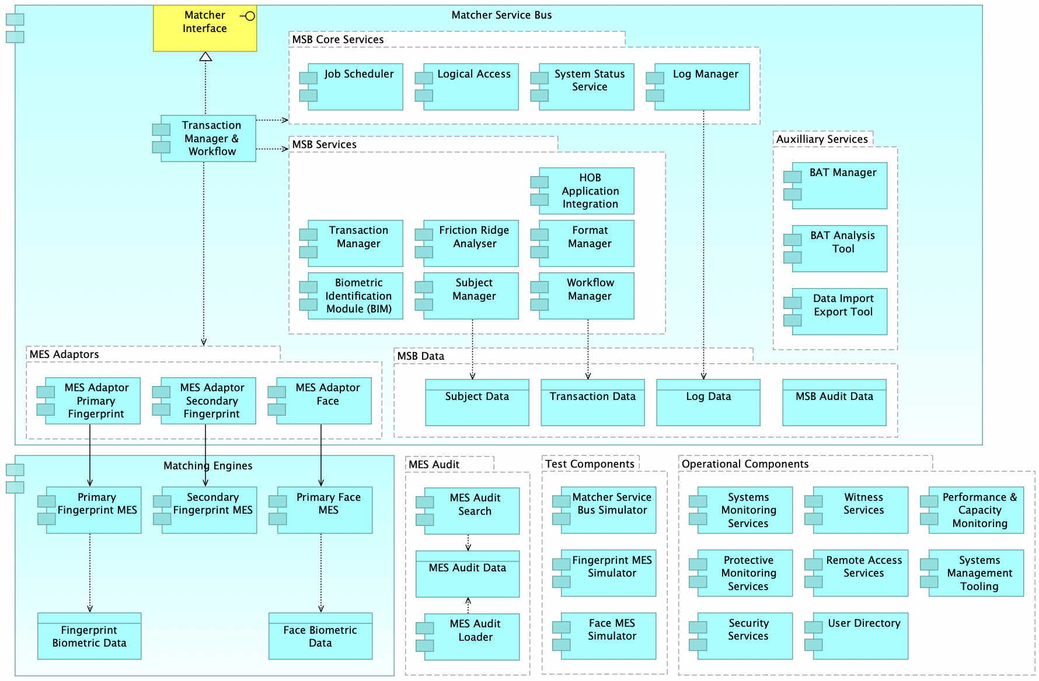

Figure 3 – Component Model Overview

### Component Descriptions

| Subsystem | Component | Description / Main Responsibility |
| --- | --- | --- |
| MSB | Matcher Interface | Presentation of matcher interface for use by consuming systems in HOB Central. |
| Transaction Manager & Workflow | Overarching workflow and processing logic to handle biometric processing requests, including orchestration of other components, and managing the separation of bulk transactions.  This component also manages calls to HOB Central systems for asynchronous responses and to invoke the Retrieve Samples service. |
| MSB – Services | Transaction Manager | Manage transactions to the MES and to HOB Central, based on the type of transaction (TOT), including handling asynchronous requests, message queueing and message prioritisation based on the defined priority in the message and TOT. |
| Subject Manager | Manage the storage of data about the subject: biographic (e.g. gender, year of birth), and biometric templates. Data items have a unique identifier and no personally identifiable information. |
| Workflow Manager | Manage transaction state, tracking the progress of each request through the workflow steps. |
| Friction Ridge Analyser | Perform biometric image processing, specifically to calculate NFIQ / NFIQ2 quality scores, to segment single fingerprints, and to integrate with the MES to perform encoding and quality analysis. |
| Format Manager | Perform validation of incoming messages against the XSD message schema, and against the TOT schema to confirm that all required fields are populated and that the message is structurally correct. |
| HOB Application Integration Module | This BMPS specific module handles lookup and routing to the correct matcher deployment instance (MDI), mapping NIST fields to internal metadata structures and implements logic for reconciliation which is specific to this solution.  The reconciliation logic queries the MSB and MES data to report the BMPS consistency to central which will then make API calls to correct. |
| Biometric Identification Module (BIM) | Provides a matcher agnostic interface for the MSB components to use, and manages requests to the relevant MES adaptors. |
| MSB Core Services | Log Manager | Manage business and audit logs, SLA/KPI logs and transaction performance logs, including recording key events and timings in the transaction lifecycle. Data managed by this component is fed to other components including the Audit Data component, Systems Monitoring Services, and Performance & Capacity Monitoring. |
| Logical Access | Manage access control. |
| System Status Service | Health-check service used by the load-balancer to identify unhealthy servers to be removed from processing requests. This invokes other components with a dummy transaction to test the overall system health. |
| Job Scheduler | Manage scheduling of tasks / jobs |
| MSB - Aux | BAT Manager | Biometric accuracy test tooling, to configure and perform tests/ |
| BAT Analysis Tool | Tool to analyse and present the results of biometric accuracy tests. |
| Data Import Export Tool | Tool for bulk import/export of data into the MSP. |
| MSB – Data | Subject Data | Data about a matcher subject (person) including biometric templates and biographic data. |
| Transaction Data | Data managed by the Workflow Manager component track the progress of each request through the workflow steps. |
| Log Data | Holding log entries of system data for diagnostic and performance purposes, as well as feeding the Audit data component, Systems Monitoring Services, and Performance & Capacity Monitoring. |
| MSB Audit Data | Audit data recording user activity and changes within the MSB. This data is initially recorded in the MSB database and is transferred to this Audit data store for long-term storage (10-year retention). |
| MSB - Adaptors | MES Adaptor Primary Fingerprint | Adaptor component to enable the MSB to communicate with the primary fingerprint MES. |
| MES Adaptor Secondary Fingerprint | Adaptor component to enable the MSB to communicate with the secondary fingerprint MES. |
| MES Adaptor Face | Adaptor component to enable the MSB to communicate with the face MES. |
| MES | Primary Fingerprint MES | Primary matching engine for fingerprints. |
| Secondary Fingerprint MES | Matching engine (orthogonal) for fingerprints used for re-ranking. |
| Primary Face MES | Matching engine for face. |
| Fingerprint Biometric Data | Storage of the biometric template generated from the minutiae identified from a fingerprint image. |
| Face Biometric Data | Storage of the biometric template generated from the features within a face image. |
| MES Audit | MES Audit Search | Provide search and dashboard capabilities to the audit data held in the MES Audit Data component. |
| MES Audit Data | Storage of the MES audit data in a search optimised repository. |
| MES Audit Loader | Component to load audit data into the MES Audit Data store. |
| Op Services | Witness Services | Services to provide a quorum to prevent split-brain clusters in DR scenarios. |
| Remote Access Services | Services to enable remote connection from support locations via thin clients. |
| Systems Monitoring Services | Services to manage the health of the matcher system and to show dashboards / raise alerts to highlight issues. |
| Systems Management Tooling | Tooling to support ITIL management of the ongoing services, including incident / problem management and CMDB. |
| Performance & Capacity Monitoring | Component to track performance and capacity including KPI reporting on transaction processing times. |
| User Directory | Supports authentication and authorisation of user access. |
| Protective Monitoring Services | SIEM (Security Information & Event Management) services to provide threat detection and security incident management of security events within the MSP. |
| Security Services | Security management tooling including anti-virus and vulnerability scanning. |
| Test Services | Matcher Service Bus Simulator | Component that simulates the MSB, for use in integration testing by Central system teams. |
| Fingerprint MES Simulator | Component that simulates the fingerprint MES, for use during MSB development without a real MES installation available. |
| Face MES Simulator | Component that simulates the face MES, for use during MSB development without a real MES installation available. |

### Component Change Summaries

The diagrams and tables in the sub-sections that follow identify the changed components for each stage and the nature of the changes. This has been used as the basis for constructing the proposed project plan.

Note the following colour scheme is used in the diagrams:

* Red – Significant change or need to build from scratch
* Amber – Some change / test & redeploy
* Blue – Component in place and being reused. No / very minor change expected.

These changes will be summarised for each of the following project phases as defined in Schedule 6.1 Implementation Plan v1.0 Final:

* Stage 1 initial fingerprint capability delivery and rollout
* Fingerprint base capability validation
* Face base capability validation
* Stage 2 – 5 rollout (note these have been compressed into a single section for brevity)

### Stage 1 Change Summary

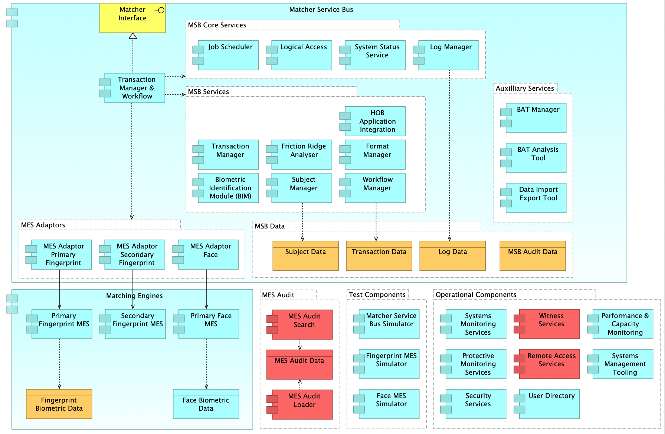

Figure 4 – Component Changes – Stage 1

Stage 1 is understood to be mostly build complete at the time of contract commencement, but with changes required to:

* take on the running of the service, and replacing services that are currently hosted / provided by the incumbent supplier
* implement a new MES audit capability
* implement network segregation between business and management traffic and data
* perform data migration from HOB Central (IDENT1)

| Subsystem | Component | Change Description |
| --- | --- | --- |
| Operational components | Witness Services | New witness services need to be established to host services to act as tie-breakers to prevent split-brain problems in certain DR scenarios. As described in Architecture Decision 3 (AD3) it is proposed to host these witness services in data-centres which host other secure Home Office services: Kyndryl Portsmouth and IBM Hursley.  The changes comprise:   * Migrating the existing witness servers from incumbent sites which will provide:   + Windows file share witness for Microsoft SQL Server   + NetApp witness software   + IDEMIA witness software   Associated network connectivity will be established from Crown Hosting to these locations and is described in the infrastructure section of the solution outline. |
| Operational components | Remote Access Services | For connectivity between the two IBM support sites and the MSP data centres, we propose to extend the use of the existing Juniper SRX devices hosted at each data centre and to create secure site-to-site IPsec VPN tunnels to each support site over the Internet.  This will include provision and deployment of Fujitsu thin client devices in the support sites and establishing network connectivity to the Crown Hosting data-centres. |
| MES Audit | MES Audit Search | Implement a new MES Audit capability as one of the stage 1 ‘additional services’ using a search optimised repository.  See section *4.9 - Audit (including additional solution)* for further details. |
| MES Audit Data |
| MES Audit Loader |
| MSB Data | Subject Data | Infrastructure changes as part of segregation of management and business traffic as one of the stage 1 ‘additional services.  The MSB and audit databases need to be moved from the management to the business zone as part of this change.  See section *3.7 - Network Separation* for further details |
| Transaction Data |
| Log Data |
| MSB Audit Data |
| MES | Fingerprint Biometric Data | Data migration and storage of the initial fingerprint data collections. See sectio*n 2.3.1 - Data Migration and Parallel Run / Cutover Approach* |

### Fingerprint Base Capability Validation - Change Summary

The remaining fingerprint functionality (i.e. latent marks) is understood that have been implemented as part of the incumbent delivery. The remaining activity in this phase is to complete formal system testing of this functionality. This extends beyond the initial operating capability of latent mark to print search which is part of stage 1. This functionality comprises:

* Print to print (various operations)
* Print to mark (various operations including fingerprints and palms)
* Mark to mark (various operations including fingerprints and palms)
* Orthogonal re-ranking for the above

No specific performance or OAT is required as the testing during stage 1 has been at the full fingerprint volumes and using all system components. In the programme plan a short period of performance and OAT regression testing is included to verify that the system is still operating as expected from an NFR perspective after any changes that have been made for defects identified during system testing.

The only functional change that is anticipated is to update the Matcher Subsystem Simulator to handle any remaining fingerprint functionality.[4] System testing may necessitate minor changes to components to respond to defects or change requests, but these will not be depicted here, and will be handled as they are identified.

Steps associated with rollout of this functionality (e.g. data migration, SIT, UAT) are not included in this stage and will be part of the later rollout phase.

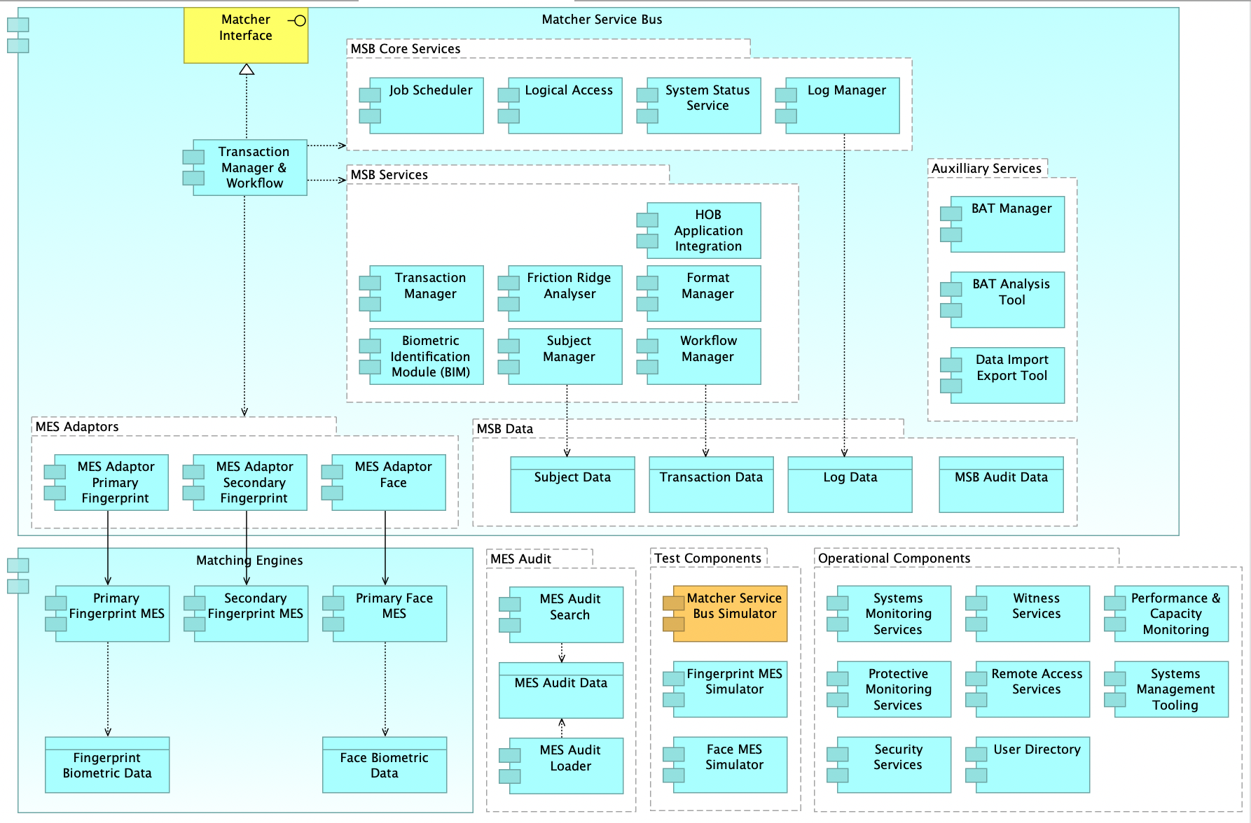

Figure 5 – Component Changes – Fingerprint Base Capability Validation

| Subsystem | Component | Change Description |
| --- | --- | --- |
| Test Components | Matcher Service Bus Simulator | Updates to simulate new stage 2 functionality for Central systems to test with |
| Matching Engines | Fingerprint Biometric Data | Migration and storage of the new latent data collections |
| MSB Data | Subject Data | Migration and storage of the new latent data collections |

### Face Base Capability Validation - Change Summary

The changes for the face base capability are to implement and test face matching capability for use by immigration and law enforcement purposes in the later rollout phases.

This new functionality comprises at its core:

* Verification of face (1:1)
* Search of face (1:M)

This includes implementation of new MSB workflows for face matching, implementation of a new face MES to perform biometric matching, build out of additional server capacity (described in the infrastructure section) and full functional and non-functional testing including system acceptance BAT.

This stage does not include rollout activities including data migration, system integration testing, UAT, live readiness / cutover and BAT baseline testing.

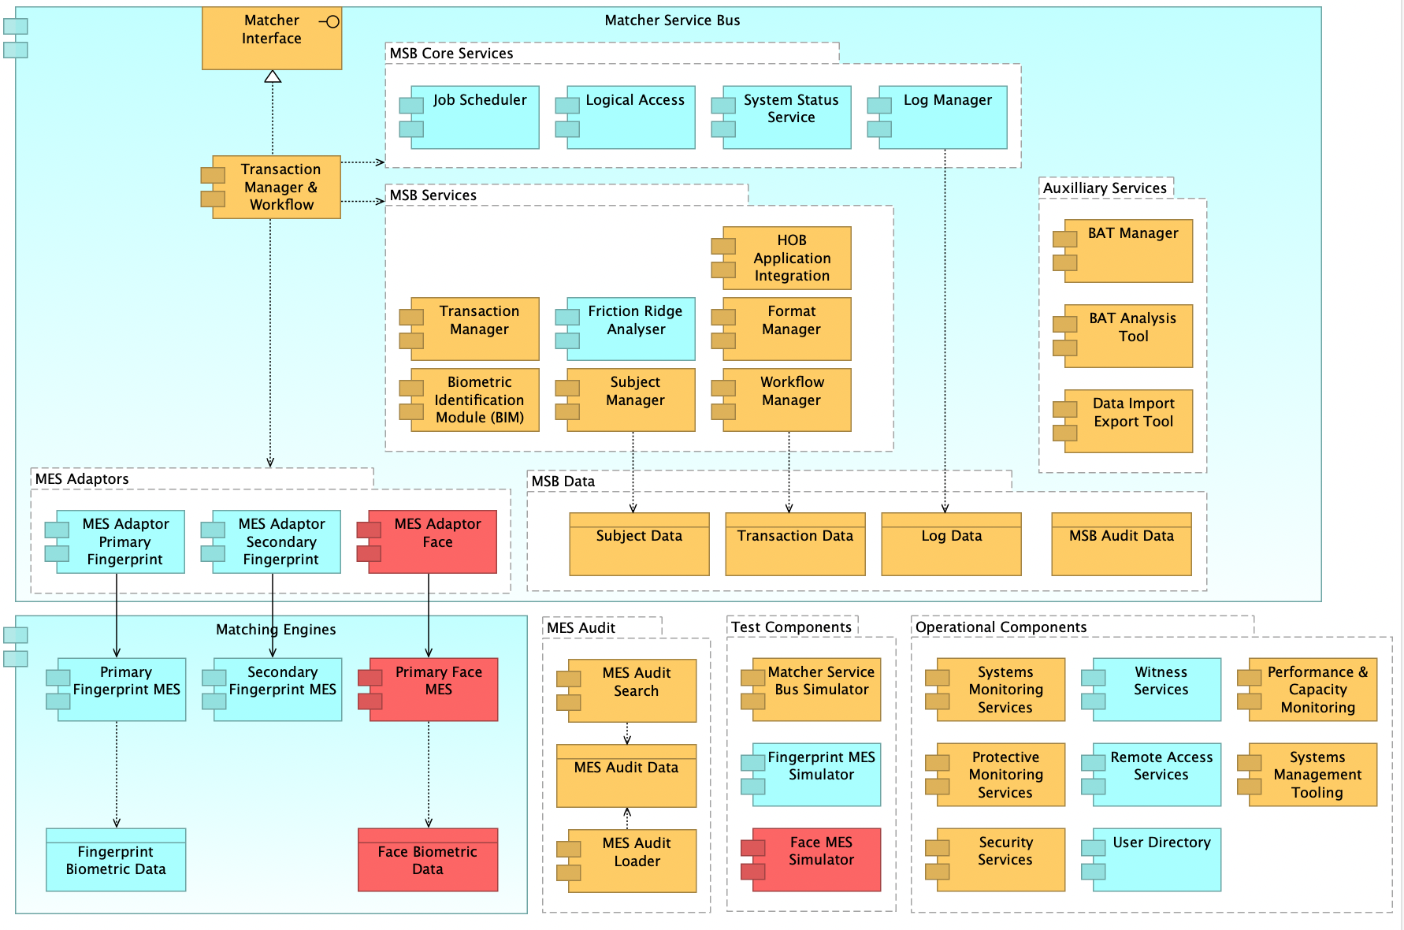

Figure 6 – Component Changes – Face Base Capability

| Subsystem | Component | Change Description |
| --- | --- | --- |
| MSB | Matcher Interface | Updates to interface to include face elements (e.g. update XSDs). Re-use and potential minor amendments to existing interface to handle fingerprints from IABS. |
| Transaction manager & workflow | Extend workflow logic to handle new face search. |
| MSB – Services | Transaction Manager | Updates to management of transactions to the MES and to HOB Central, to manage new priority and queueing logic for face matching messages. |
| Subject Manager | Updates to data storage of biometric templates and biographic data related to face matching. |
| Workflow Manager | Updates to manage transaction state for face matching workflow steps. |
| Format Manager | Updates to perform validation of incoming face messages against the XSD message schema, and against the TOT schema to confirm that all required fields are populated and that the message is structurally correct. |
| HOB Application Integration Module | Updates to the BMPS specific module to handle face specific functionality. This may include items including routing to the correct matcher deployment instance (MDI), data mapping from NIST fields to internal metadata structures and logic for reconciliation between MSB and MES to report the BMPS consistency to Central to then make API calls to correct. |
| Biometric Identification Module (BIM) | Updates to integrate from the MSB to the new face MES adaptor. |
| MSB – Aux | BAT Manager | Updates to BAT Manager and BAT Ping to manage the selection of probe and candidate records and perform searches required for face BAT activities |
| BAT Analysis Tool | Enhancements to enable biometric analysis for face records |
| Data Import Export Tool | Updates to support import/export of new collections of biometric data (i.e. face) |
| MSB – Data | Subject Data | Updates to data structures to support storage of face related data |
| Transaction Data |
| Log Data |
| MSB Audit Data |
| MES Adaptors | MES Adaptor Face | Implement adaptor to handle interactions with face MES. Design consideration about the level of re-use from the existing primary fingerprint adaptor, as both are integrating with the IDEMIA matching engine. |
| MES | Primary Face MES | Implementation and configuration of Face MES capability including deployment of underlying infrastructure |
| Matching Engines | Face Biometric Data | Migration and storage of the new face data collection for immigration purposes from IABS |
| MES Audit | MES Audit Search | Updates to MES audit search to ingest, store and expose face audit data |
| MES Audit Data |
| MES Audit Loader |
| Op Services | Systems Monitoring Services | Updates to system monitoring services to take feeds from new face MES, and to configure appropriate alerts and thresholds |
| Performance & Capacity Management | Updates to performance and capacity management to incorporate the performance of face matching |
| Systems Management Tooling | Updates to systems management (ITIL) tooling to include information relevant to face matching e.g. new operational procedures / knowledge base articles |
| Security Services | Updates to AV and vulnerability scanning to extend to face MES |
| Protective Monitoring Services | Updates to extend protective monitoring to face MES |
| Test Components | Matcher Service Bus Simulator | Updates to simulate new face matching functionality, adding support for testing face interactions, for Central systems to test with |
| Face MES simulator | Establish new face MES simulator for MSB development without a real MES installation available |

### Stage 2 - 5 Rollout - Change Summary

This section summarises the changes required for the rollout of each of stages 2 – 5. There is little system change required at his point as the previous phases have implemented and tested the required system changes.

The changes in these stages are primarily the data migration of the in-scope fingerprint or face templates from HOB Central Systems and final testing (system integration test / user acceptance test). Final testing may necessitate minor changes to components to respond to defects or change requests, but these will not be depicted here, and will be handled as they are identified.

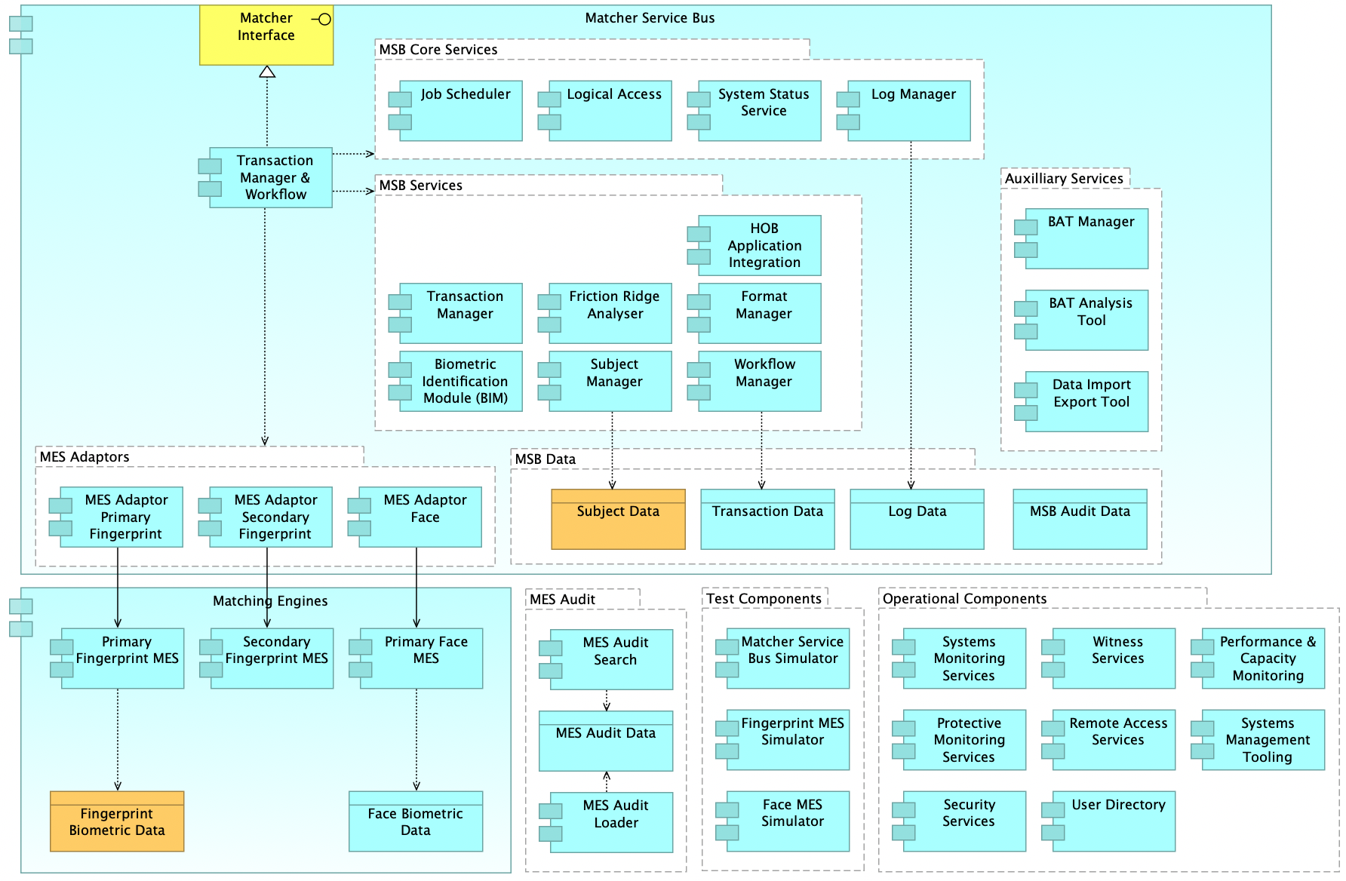

Figure 7 – Component Changes – Stage 2-5 Rollout

|  |  |  |
| --- | --- | --- |
| Subsystem | Component | Change Description |
| Matching Engines | Face Biometric Data | Migration and storage of the new face data collections |
| Matching Engines | Fingerprint Biometric Data | Migration and storage of the new immigration fingerprint and law enforcement latent mark data collections |
| MSB Data | Subject Data | Migration and storage of the new data collections for each stage, for face and fingerprints |

## Data Architecture

Our understanding of the existing solution is that the main data structures and data stores are implemented as part of stage 1. Our proposal is to build on this design, and to make changes only where required to implement functionality or data attributes that are not supported in the existing stage 1 implementation.

The following sub-sections describe our envisaged conceptual data model based on the ITT materials, mapping of key entities to the data stores which implement the model, and our proposed approach to data migration. We will use this as the basis for update as part of service take-on activities as we learn more about the detailed data implementation, or adopt and update the existing model that is handed over.

### Conceptual Data Model

Presented in Figure 9 is a conceptual data model describing the key entities that are part of the MSP processing. It should be noted that this is a conceptual model and these entities will potentially be delivered across multiple physical databases.

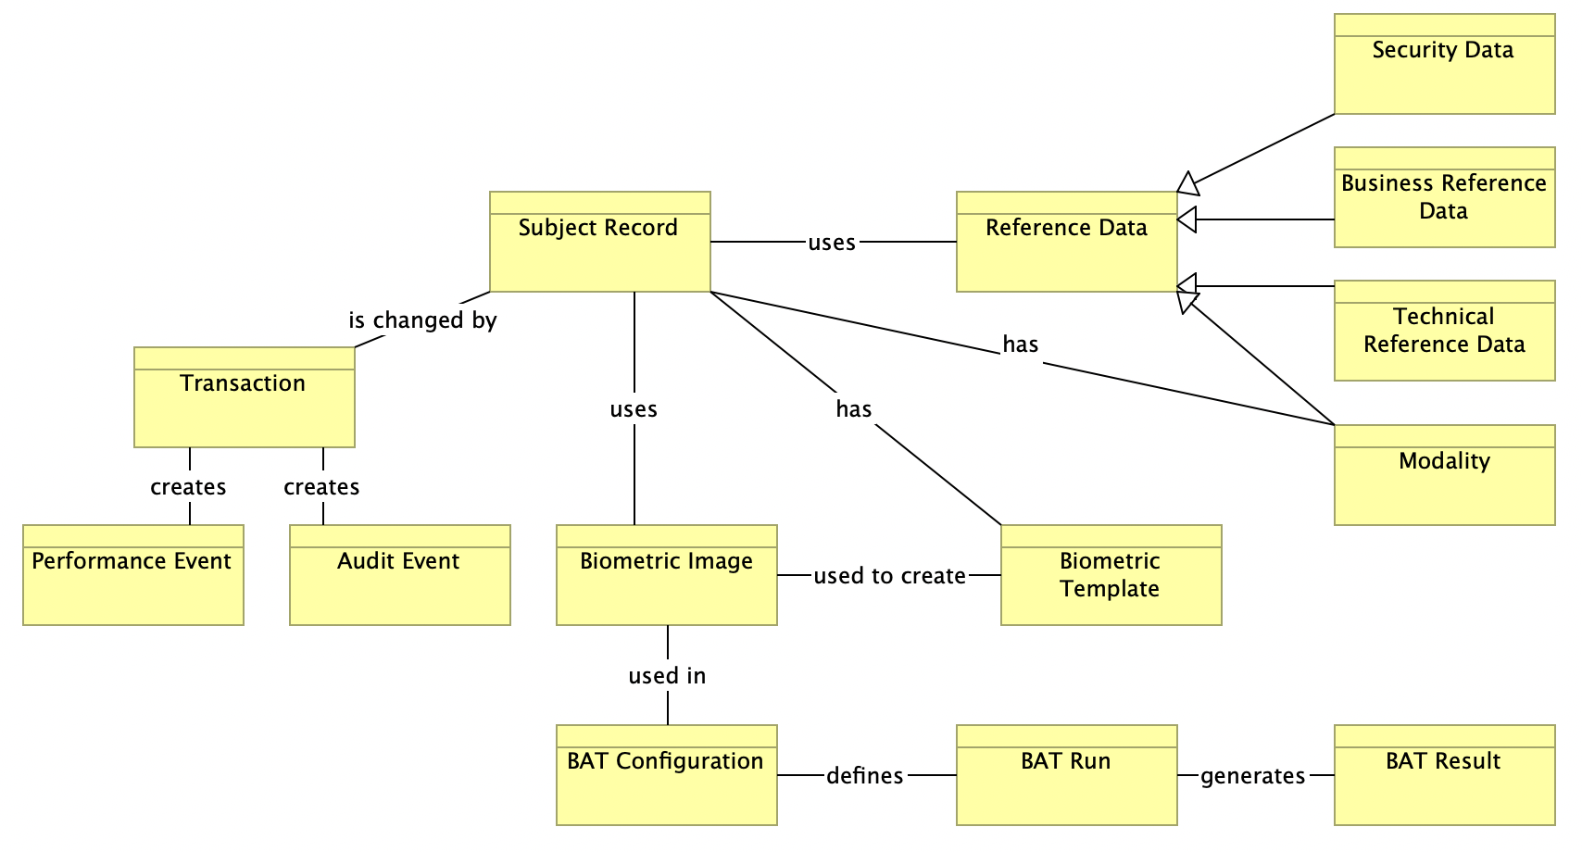

Figure 9 – Conceptual data model

| Domain | Entity | Description |
| --- | --- | --- |
| Non-Biometric | Subject Record | Holds metadata related to a specific subject held on an MES including reference number biographic data for search filtering e.g. gender, nationality etc. |
| Biometric | Biometric Template | Holds the digital representation generated from the unique biometrics features (e.g. fingerprint minutiae) identified in an image. |
| Biometric | Biometric Image (temporary) | Holds binary object data relating to a biometric image (e.g. print, latent, face). This will typically only be stored until the template data has been derived from the image and will then be deleted. |
| Transaction | Transaction | Holds metadata relating to a transaction including its priority, state and date of receipt. Also holds the non-binary business data received in a transaction request. Retained during the processing of an in-flight transaction and archived for a set period once transaction is completed. |
| Transaction | Performance Event | Holds any performance measurements associated with a transaction (e.g. date-time of receipt/response, date-time of request/response to MES Deployment). Used for service reporting against SLAs and live tracking of system performance. |
| Audit | Audit Event | Holds business audit event data relating to an action or change that has occurred during the processing of a transaction. |
| Reference | Reference Data | Sets of data used to define lists of values to be used business definitions, and for managing application behaviour. Realised using the subtypes described in the following rows. |
| Reference | Technical Reference Data | A set of control data owned by the technical team that the application uses in the processing of transactions (e.g. transaction priority mappings, sync/async mode lookup). |
| Reference | Business Reference Data | A set of permissible values owned and defined by the Business which enforces the quality of the business data used by the system. E.g. valid gender, nationality etc. values |
| Reference | Security Data | Defines the users, groups, access controls and permissions with which the system manages the security of the solution. |
| Reference | Modality | A notable item of business reference data which defines the type of biometric record/sample (i.e. finger, latent, face) |
| BAT | BAT Configuration | Holds the configuration for each type of Biometric Accuracy Test, including modality, target matcher, test type and a list of the BAT records and/or BAT images that make up the dataset for the test. |
| BAT | BAT Run | Represents an instance of running an accuracy test using a specific BAT Configuration. For example, an instance of running a monthly 1:M BAT Ping test using a reduced probe set. |
| BAT | BAT Result | Holds the biometric search/verification results generated by individual Biometric Accuracy Test instances. This is held for future analysis by the business. |

## Data Stores

Note this section focuses on the data-stores required to hold the business data entities described in the conceptual data model. There are a number of other operational datastores to hold for example configuration management data, which will not be described here and are part of the infrastructure model. Note some of these data-stores may be implemented as sets of tables within the same physical database.

| Data Store | Purpose | Data entities stored |
| --- | --- | --- |
| MSB Database | Storing entities the matcher service bus requires to process matcher service requests | * Subject Record * Biometric Template * Reference Data (all sub-types) |
| MSB Transaction Database | Storing the transactions that the matcher processes, including temporary storage of the biometric image used to derive the biometric template | * Transaction * Biometric Image (temporary only) |
| MSB Audit database | Data storage of audit events from the MSB for later investigation | * Audit Event |
| Primary fingerprint MES data | Storage of fingerprint biometric templates for matching | * Biometric Template (print/latent) |
| Face MES data | Storage of face biometric templates for matching | * Biometric Template (face) |
| MES Audit database | Data storage of audit events from the MES for later investigation | * Audit Event |
| BAT Database | Data store to support the planning, execution and reporting of BAT tests | * BAT configuration * BAT run * BAT result |
| Athene CMIS | Storage and reporting of performance and capacity data | * Performance Event |

### Data Migration and Parallel Run / Cutover Approach

An important activity throughout all stages is the data migration of biometric images (to create new biometric templates) and matcher records from existing systems, and the approach to achieving this. There are two main approaches available:

* bulk migration via offline storage device(s)
* online transfer directly from the source systems using the matcher interface

From the information provided within the ITT, we believe that both approaches are viable. An online transfer approach is preferred as it has significant advantages:

* simplifies the migration with removal of physical transfer and related transport plan / activities and reduces the risk of errors occurring
* exercises the real business interface, using the same processing as will happen with BAU transactions in normal usage, providing further confidence
* reduces the support effort involved in the migration

The potential challenge to adopting this approach will be the potential data processing / transfer rates of the source systems being sufficient to meet the desired timelines. This will need to be assessed during detailed planning and transition activities, working with the source system provider. If this approach proves unfeasible, then the bulk migration using a physical storage device approach will be used.

A further challenge for the online approach may be the additional load on the system to process data migration alongside normal business traffic. This will be assessed as part of performance and capacity planning and during performance testing. It is noted that each data centre is sized to be able to run 100% of the load (for DR scenarios), which implies in normal circumstances that there is 100% spare capacity which can be used for data migration traffic, giving confidence that this is sufficient.

From a logical perspective, the migration of existing law enforcement and immigration data will follow a well-established migration pattern involving the following phases:

1. Analyse existing data. Establish mapping from source to target system including transformation rules.
2. Establish schedule using incremental migrations of historic ‘windows’ of datasets of ever decreasing size (see Figure 10).
3. Design and develop migration scripts; based on use of strategic matcher services – details here will vary based on the online or physical transfer approach.
4. Design and develop validation/reconciliation – based on record counts, automated spot check validation and old vs. new processing.
5. Execute test migration to prove the processing and overall approach. Initially this will use synthetic data and subsequently with pseudo-anonymised data from Central systems to provide as representative a test as possible.
6. Execute each migration in the live environment. If possible this will be scheduled during times of low system usage to avoid impact to live operation (note - it may not be possible to only run ‘out-of-hours’ like this, depending on the volume of records, time-window within which migration needs to occur and speed of extraction from the source system).
7. From the point of the final migration, to support parallel running, the source systems will now need to send any new records to HOB Matcher over the online interface as a business-as-usual (BAU) interaction, alongside saving them internally. For an offline migration this may require a period of data ‘freeze’ for the source system with no updates performed until the final migration is completed, or alternatively the source system will queue up any new records (deltas) in this period and send them as a small online ‘delta batch’ to matcher using the online BAU interface before beginning sending each new record in turn for normal parallel running.
8. Once there is sufficient confidence from the parallel running period, the source system is updated to only send requests to matcher, and to remove the internal matching processing.



Figure 10 – Data Migration High Level Approach

#### Changes to existing systems for data migration

The existing IDENT1 and IABS systems will require changes to support the data migration. This includes either:

* **Online**: Updates to interface with Matcher services to:
  + send data updates (enrol, update, delete) through the Matcher interface
  + interface with Matcher services to perform reconciliation of records (using ListRecords) between the two systems after migration runs
* **Physical**: Activity to bulk export data to a physical device in a format suitable for import to matcher

For either approach, the existing systems will need to:

* support parallel running by sending updates to matcher as well as saving internally
* support parallel running by calling strategic matcher to run perform search / verification, alongside using their internal matcher. This either needs to:
  + be able to switch between which system’s matching result to use as the output,
  + or for a confidence mechanism to be implemented to compare the two results and determine which to use as the output

#### Data migration volumes and durations

An estimate of the expected data migration duration is required to support creating the programme plan. To give an early view ahead of more detailed performance data being available, this is estimated using the number of records to migrate for each stage and an assumed extraction rate from each source system. This is based on the BMPS volumetric model[5], and the data storage and data migration volumes document[6]

This gives the following records to migrate, shown per gallery in the first table and summarised per stage in the second table.

| Gallery | Records (2019) | Annual Growth | Stage | Years of growth from 2019 to migration point | Projected Records to migrate |
| --- | --- | --- | --- | --- | --- |
| Gallery 1 | 8,427,240 | 2.0% | migrate in 18a |  |  |
| Gallery 2 | 21,632,000 | 4.0% | migrate in 19 |  |  |
| Gallery 3 |  | N/A | N/A |  |  |
| Gallery 4a | 12,100 | 10.0% | Stage 1 | 4 | 16,940 |
| Gallery 4b | 121 | 10.0% | migrate in 4a |  |  |
| Gallery 5a | 320,000 | 0.0% | Stage 1 | 4 | 320,000 |
| Gallery 5b | 250,000 | 0.0% | migrate in 5a |  |  |
| Gallery 6a | 624,240 | 2.0% | migrate in 22a |  |  |
| Gallery 6b | 510,050 | 1.0% | migrate in 22b/22a |  |  |
| Gallery 7a | 674,160 | 6.0% | migrate in 20a |  |  |
| Gallery 7b | 42,250 | 30.0% | migrate in 20b |  |  |
| Gallery 8a | 1,273,080 | 3.0% | migrate in 21a |  |  |
| Gallery 8b | 30,603 | 1.0% | migrate in 20b |  |  |
| Gallery 9 |  | N/A | N/A |  |  |
| Gallery 10 | 5,066,748 | 2.0% | not used |  |  |
| Gallery 11a | 2,121,053 | 0.5% | Stage 2 | 6 | 2,184,684 |
| Gallery 11b | 424,360 | 3.0% | Stage 2 | 6 | 500,745 |
| Gallery 12a | 10,506 | 2.5% | Stage 2 | 6 | 12,082 |
| Gallery 12b | 1,051 | 2.5% | Stage 2 | 6 | 1,208 |
| Gallery 13a | 6,250 | 25.0% | Stage 2 | 6 | 15,625 |
| Gallery 13b | 1,690 | 30.0% | Stage 2 | 6 | 4,732 |
| Gallery 14a | 22,472 | 6.0% | Stage 2 | 6 | 30,562 |
| Gallery 14b | 4,368 | 4.5% | Stage 2 | 6 | 5,547 |
| Gallery 15a | 36,058 | 1.5% | Stage 2 | 6 | 39,303 |
| Gallery 15b | 3,091 | 1.5% | Stage 2 | 6 | 3,369 |
| Gallery 13-14 |  | N/A |  |  |  |
| Gallery 16a | 125,000 | 0.0% | Bureau collection |  |  |
| Gallery 16b | 60,000 | 0.0% | Bureau collection |  |  |
| Gallery 16c | 15,150 | 0.5% | Bureau collection |  |  |
| Gallery 16d | 3,025 | 10.0% | Bureau collection |  |  |
| Same-Day-Search | 5,513 | 5.0% | Bureau collection |  |  |
| Gallery 17a | 208,080 | 2.0% | Bureau collection |  |  |
| Gallery 17b | 159,135 | 3.0% | Bureau collection |  |  |
| Gallery 17c | 120,000 | 0.0% | Bureau collection |  |  |
| Gallery 17d | 60,000 | 0.0% | Bureau collection |  |  |
| Gallery 18a | 26,522,500 | 3.0% | Stage 1 | 4 | 29,705,200 |
| Gallery 18b | 17,472,400 | 4.5% | migrate in 18a |  |  |
| Gallery 19 | 32,448,000 | 4.0% | Stage 3 Fingerprint | 6 | 40,235,520 |
| Gallery 20a | 1,058,000 | 15.0% | Stage 1 | 4 | 1,692,800 |
| Gallery 20b | 42,250 | 30.0% | migrate in 20a |  |  |
| Gallery 21a | 1,236,270 | 1.5% | Stage 1 | 4 | 1,310,446 |
| Gallery 21b | 25,503 | 1.0% | migrate in 21a |  |  |
| Gallery 22a | 600,000 | 0.0% | Stage 1 | 4 | 600,000 |
| Gallery 22b | 510,050 | 1.0% | migrate in 22a |  |  |
| Closed Set Search | 300 | 0.0% | No records to migrate |  |  |
| Gallery 23 | 5,101 | 1.0% | Migrated in phase 1b |  |  |
| Gallery 30 | 33,000,000 | 4.0% | Stage 3 Face | 6 | 40,920,000 |
| Gallery 31 | 70,000,000 | 0.0% | Stage 4 | 7 | 70,000,000 |
| Gallery 32 | 200,000 | 0.0% | Stage 4 | 7 | 200,000 |
| Gallery 33a | 500,000 | 500,000 increase per annum | Stage 4 | 7 | 4,000,000 |
| Gallery 33b | 4,350,000 | 0.0% | Stage 4 | 7 | 4,350,000 |
| Gallery 34 | 200,000 | 0.0% | Stage 4 | 7 | 200,000 |
| Gallery 35 | 15,000,000 | 0.0% | Stage 5 | 7 | 15,000,000 |

Summarising the records to transfer into each stage provides the following record counts. Projected migration duration has been calculated based on the assumptions of:

* 3 records per second for stage 1 (as per data migration HLD)
* 6 records per second for all remaining stages (as advised during negotiation period)

| Stage | Records (2019) | Records inc. Growth | Records per Second | Migration Weeks |
| --- | --- | --- | --- | --- |
| Stage 1 | 29,748,870 | 33,645,386 | 3 | 19 |
| Stage 2 | 2,630,898 | 2,797,858 | 6 | 1 |
| Stage 3 Face | 33,000,000 | 40,920,000 | 6 | 11 |
| Stage 3 Fingerprint | 32,448,000 | 40,235,520 | 6 | 11 |
| Stage 4 | 75,250,000 | 78,750,000 | 6 | 22 |
| Stage 5 | 15,000,000 | 15,000,000 | 6 | 4 |

For the longer migration periods, especially for stage 1, we will investigate ways to take the long data migration period off the project delivery critical path. One option to consider is to begin the extraction process earlier from Central, but not process the messages all the way through to the MES until other predecessor activities (e.g. network separation additional service) have completed. This could be achieved by receiving messages from Central and then queueing them, either within the transaction management component of the MSB, or in a persistent message queue. This is supported by the associated transactions (enrol, update, delete) being asynchronous in nature.

## SOA Service Architecture

Our understanding of the existing solution is that the majority of the services will be implemented as part of stage 1, and are designed to be generic. This is expected to enable them to be reused for new purposes e.g. Face, with minimal changes to interface specifications.

Our proposal, based on the information currently available, is to build on this existing SOA design, and to make changes only where required to implement functionality or data attributes that are not supported in the existing implementation.

Based on our current understanding of the solution requirements from the ITT materials and our wider understanding of biometric matching solutions, below is shown the basis of an envisaged SOA services catalogue. We would use this as the basis for update and extension (e.g. adding more columns describing details of inputs, outputs, URLs and other data useful to the project and support team) as part of service take-on activities as we learn more about the detailed implementation, or adopt and update the existing model that is handed over.

| Service | Type | Description |
| --- | --- | --- |
| List | Async | Orchestrates the retrieval of a list of records from a Matcher, Collection or filtered set.  The service coordinates:   * Retrieval of a set of matcher record reference numbers * Retrieval of meta-data |
| Retrieve | Sync | Returns matcher records identified by the matcher record references held by central systems |
| Retrieve From Central | Sync | Retrieves biometric images from HOB Central |
| Quality Assess  (Part of Analyse service) | Sync | Quality assesses the provided biometric images using a Matcher Engine and/or the NFIQ Processor component |
| Encode (Part of Analyse service) | Sync | Orchestrates the encoding of biometrics |
| Segment (Part of Analyse service) | Sync | Orchestrates the segmentation of ‘slap’ fingerprint images into a set of individual fingerprint images |
| Enrol | Async | Fulfils a request to add a record to a specified Matcher collection, generating a biometric template and storing it. |
| Update | Async | Updates a record that has previously been added to Matcher, performing either a full replacement, or a partial update |
| Delete | Async | Deletes a biometric record from Matcher.  The service coordinates:   * Deletion of the templates on the targeted Matcher collection * Deletion of the corresponding record in the MSB |
| Verify | Sync | Performs a 1:1 verification of supplied biometric sample(s) against either a supplied record or a previously saved record. |
| Search | Async | Searches using a provided biometric record against the specified collections (1:M search), including the option to re-rank using an orthogonal MES. |
| Closed Set Search | Async | Performs a closed set search, to either:   * search all records within a group against each other * search all records in one group against all records in a second group |

# Infrastructure architecture

## Infrastructure & Platform

The infrastructure architecture can be expressed using a number of different views at differing levels of detail, right down to physical server specifications and detailed network diagrams. Our approach for this solution outline is to describe high-level logical views of the infrastructure, to demonstrate our understanding and to enable the areas of future change to be highlighted.

For a solution outline document, based on our approach from Architecture Decision 1 to build upon the existing solution, and with the information currently available via the ITT we do not plan to fully recreate the detailed infrastructure views which we expect will already exist as part of the project documentation set.

### Location view

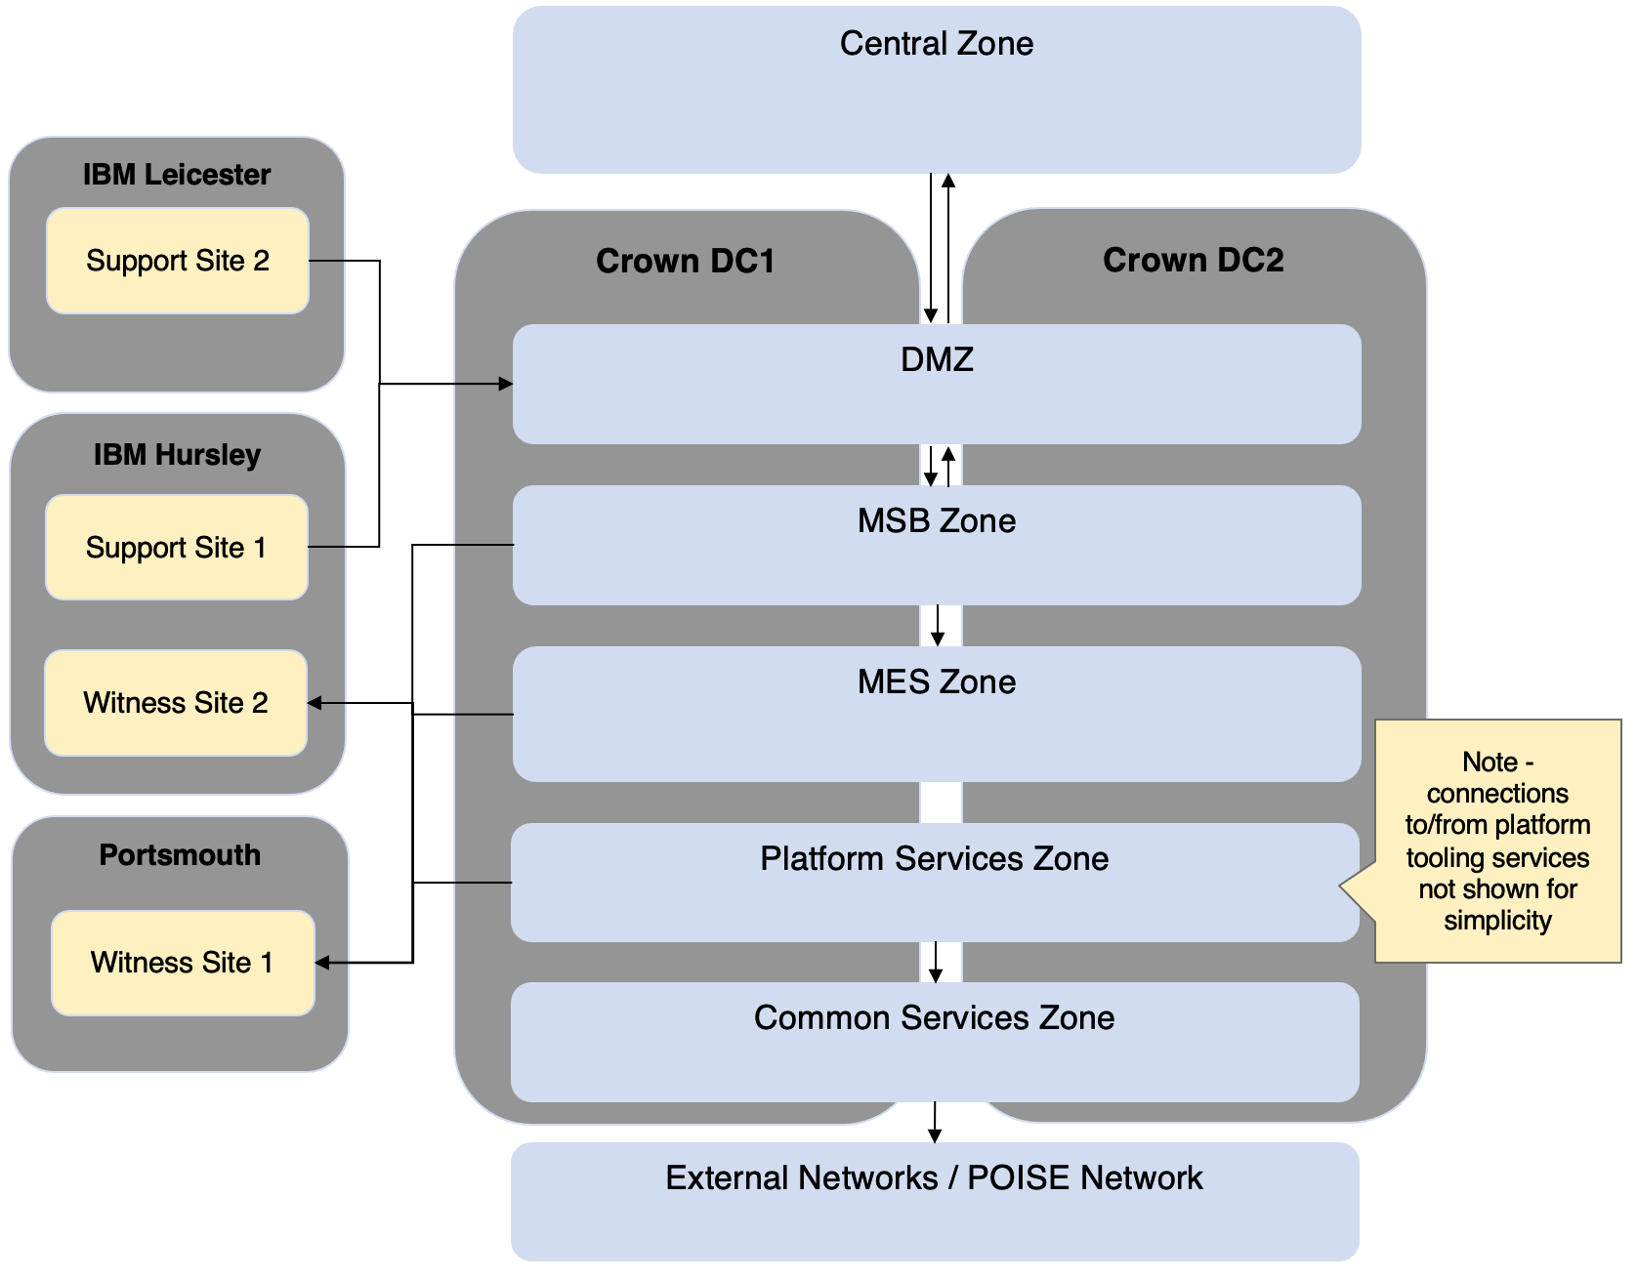

Figure 11 – Logical Location View

The purpose of each zone is summarised in the table. Note that this topology repeats across the production, pre-production 1 and pre-production 2 environments.

| Physical Location | Logical Zone | Description |
| --- | --- | --- |
| HOB Central location | Central Zone | Location of the existing matcher systems IDENT1 and IABS that will use the strategic HOB Matcher. These are understood to be migrating to a cloud location from the current on-premises hosting. |
| Crown DCs 1 & 2 | DMZ | Security zone to receive incoming requests, providing separation from the remaining matching zones, and allowing security management including content inspection of inbound requests. This logical zone is present in both physical data-centres. |
| Crown DCs 1 & 2 | MSB Zone | Zone containing the matcher services bus (BioSP) and related components e.g. BAT manager, ImpEx tool, etc. This logical zone is present in both physical data-centres. |
| Crown DCs 1 & 2 | MES Zone | Zone containing the Idemia & NEC matching engines. This logical zone is present in both physical data-centres. |
| Crown DCs 1 & 2 | Platform Services Zone | Zone containing the management software to run the service, including SIEM, systems monitoring, patching, configuration management etc. This logical zone is present in both physical data-centres. |
| Crown DCs 1 & 2 | Common Services Zone | Zone which enables connection to external networks. Used for connection to internet based services to retrieve security patches, and for access to the POISE based Service Now tooling. This logical zone is present in both physical data-centres. |
| IBM Hursley | Support Site 1 | Site used by project / support team with network connectivity to Matcher technical components using thin client / remote desktop. This connection assumed to be via the DMZ and terminated at a remote desktop server in the platform services zone. |
| IBM Leicester | Support Site 2 | Site used by project / support team with network connectivity to Matcher technical components using thin client / remote desktop. This connection is assumed to be via the DMZ and terminated at a remote desktop server in the platform services zone. |
| Portsmouth | Primary Witness Site | Location used to host the witness services used to tie-break clusters to avoid split-brain in certain DR scenarios. This will host the primary witness services that manage the cluster quorum in normal circumstances. |
| IBM Hursley | Secondary Witness Site | Location used to host the witness services used to tie-break clusters to avoid split-brain in certain DR scenarios. This will host the secondary witness services that manage the cluster quorum if the primary witness service is unavailable. |

### Operational Model

The IBM architecture method uses a concept of ‘deployment units’ to establish traceability / linkage from the application view in the component model to the infrastructure view in the operational model. This can:

* simplify the placement of application components onto server nodes by grouping components to be deployed as a collective unit or package
* or draw out relevant operational detail by splitting components or introducing supporting operational components that are not part of the logical application view or to cater for other run-time concerns e.g. some parts of a component which are resource intensive might be deployed independently

Deployment units are then mapped to ‘logical nodes’, which represent logical servers which are then placed in the appropriate locations. At this stage of operational modelling, nodes are represented as logical servers – the number of nodes in clusters and the sizing is added later at the physical node stage.

The table below maps the application components to corresponding deployment units to corresponding specified server nodes.

| Component | Deployment Unit | Logical Node | Description |
| --- | --- | --- | --- |
| Matcher Interface | DU_BioSP | LN_Bio_SP | Aware BioSP is COTS - all main MSB components deployed together |
| Transaction Manager & Workflow |
| Transaction Manager |
| Subject Manager |
| Workflow Manager |
| Friction Ridge Analyser |
| Format Manager |
| HOB Application Integration Module |
| Biometric Identification Module (BIM) |
| Log Manager |
| Logical Access |
| System Status Service |
| Job Scheduler |
| MES Adaptor Primary Fingerprint |
| MES Adaptor Secondary Fingerprint |
| MES Adaptor Face |
| BAT Manager | DU_BAT_Mgr | LN_BAT_Mgr | BAT Manager implemented standalone from main MSB using .NET |
| BAT Analysis Tool | DU_BAT_Analysis_Performix | LN_BAT_Analysis_Performix | BAT analysis implemented using Performix software |
| Data Import Export Tool | DU_Data_Impex | LN_Data_Impex | Data Impex tool implemented standalone from main MSB using .NET |
| Subject Data | DU_BioSP_DB | LN_BioSP_DB | BioSP database implemented using SQL Server |
| Template Data |
| Log Data |
| Reference Data |
| Audit Data | DU_Audit_DB | LN_Audit_DB | Audit data stored in SQL Server separate from main business data |
| n/a | n/a | LN_MES_Load_Balancer | Load-balances requests to the MES services |
| Primary Fingerprint MES | DU_Finger_MES_Idemia | LN_Finger_MES_Idemia | Note each MES is currently modelled as a single deployment unit / specified node. Subsequent versions will refine the MES deployment into nodes for different purposes. |
| Fingerprint Biometric Data |
| Secondary Fingerprint MES | DU_Finger_MES_NEC | LN_Finger_MES_NEC |
| Primary Face MES | DU_Face_MES | LN_Face_MES |
| Face Biometric Data |
| Systems Monitoring Services | DU_SysMgt_System_Center | LN_SysMgt_System_Center_SCOM | MS System Centre – Operations Manager node(s) for server monitoring |
| LN_SysMgt_System_Center_SCCM | MS System Centre – Configuration Manager node(s) for managing configuration changes |
| LN_SysMgt_System_Center_SCSM | MS System Centre – Service Manager node(s) for ITIL service management activity |
| DU_SysMgt_System_Center_DB | LN_SysMgt_System_Center_DB | Database for MS System Center components – SCOM and SCSM |
| DU_SysMgt_SolarWinds | LN_SysMgt_SolarWinds | Deployment of SolarWinds network monitoring tool central server |
| DU_SysMgt_Satellite | LN_SysMgt_Satellite | Deployment of Satellite server to manage Linux patching |
| DU_SysMgt_Ansible | LN_SysMgt_Ansible | Deployment of Ansible for automation and support of Red Hat Linux and operation of the MES. |
| Remote Access Services | DU_Remote_Desktop_Services | LN_Remote_Desktop_Services | Windows Remote Desktop Services for project/support staff to access the environment |
| DU_ThinClient_Mgt_Scout | LN_ThinClient_Mgt_Scout | Scout management service to manage thin client devices for access to the environment |
| DU_ThinClient_Mgt_Scout_DB | LN_ThinClient_Mgt_Scout_DB | Database for Scout management service |
| Performance & Capacity Management Tooling | DU_PerfMon_Athene | LN_PerfMon_Athene | Athene performance and capacity management central server |
| DU_PerfMon_Athene_DB | LN_PerfMon_Athene_DB | Database for Athene performance management |
| Protective Monitoring Services | DU_SIEM_LogRhythm | LN_SIEM_LogRhythm | LogRhythm central server and user interface for protective monitoring / SIEM |
| DU_SIEM_LogRhythm_DB | LN_SIEM_LogRhythm_DB | Database for LogRhythm |
| Security Services | DU_VulnScan_Nessus | LN_VulnScan_Nessus | Nessus central server for vulnerability scanning the environment |
| DU_AntiVirus | LN_AntiVirus | McAfee anti-virus central server |
| User Directory | DU_Active_Directory | LN_Active_Directory | Active Directory to provide directory services and user management across the environment |
| Matcher Service Bus Simulator | DU_MSB_Simulator | LN_MSB_Simulator | Test tool deployed into Central zones, to allow testing of IDENT1/IABS against a simulated version of MSB in advance of integration testing |
| Fingerprint MES Simulator | Not included in model – understood to be deployed only to Aware development environment | Not included in model – understood to be deployed only to Aware development environment | Test tools deployed in Aware development environment to enable development and testing in advance of having a MES available |
| Face MES Simulator |
| Witness Services | DU_Witness_SQL | LN_Witness_SQL | Witness Fileshare to act as tie-breaker for cluster split-brain scenarios |
| DU_Witness_NetApp | LN_Witness_NetApp | NetApp witness software to act as tie-breaker for cluster split-brain scenarios |
| DU_Witness_Idemia | LN_Witness_Idemia | Idemia witness software to act as tie-breaker for cluster split-brain scenarios |
| n/a | n/a | LN_Security_Gateway | Note – technical component, not represented in application view. |

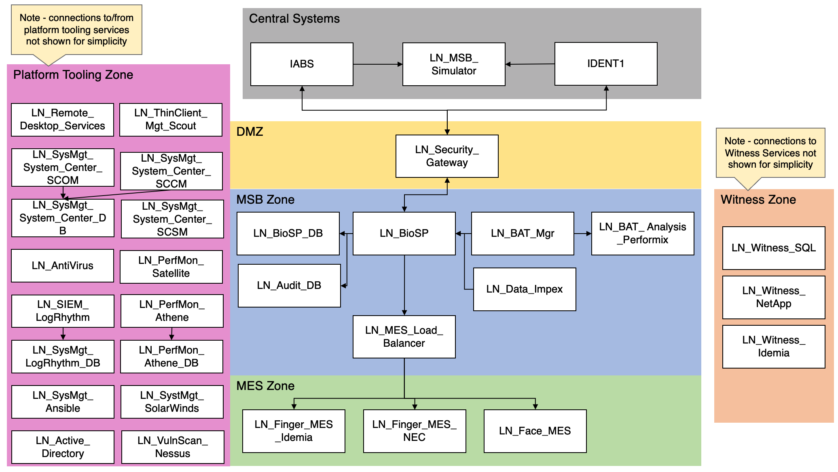

Figure 12 – Logical Operational Model

### NFRs

The subsections that follow describe how the solution will continue to be designed, developed and implemented to meet the key programme non-functional requirements (NFRs)

#### Availability & RTO

To meet the 99.9% availability requirement the solution is run active/active across the two data-centres, with each site sized to be able to handle 100% of traffic in the event of one of the sites failing. Within each site, the solution is implemented to remove single points of failure, including for example:

* Resilient physical server infrastructure, with servers split across racks within a data-centre
* Solution components deployed in clusters to provide resilience to individual application or server failure, with load-balancer health-checks used to direct traffic only to healthy members of the cluster
* Resilient network devices such as the F5 load-balancers
* SQL Server data store for BioSP running in both data-centres using SQL Server Always On availability groups with synchronous replication (transaction needs to be written to both sites before it is marked as completed)
* Resilient storage using a highly available SAN storage array with synchronous replication between sites

The recovery time objective (RTO) to be met is 0 seconds, with exceptions to this noted in the BMPS MSP Solution Design[7].

#### Data Integrity & RPO

The MSB data is stored in SQL Server running in both data-centres using SQL Server Always On availability groups with synchronous replication. This replication means that transactions need to be written successfully to both sites before being marked as complete. In the event of a single site failure, automatic failover will be triggered to the second site, allowing processing to quickly continue with no loss of data.

Databases are backed up with NetApp snapshots to provide a point-in-time copy to enable recovery of data in data corruption or deletion scenarios. To meet a recovery point objective of zero lost transactions, SQL redo logs will be used to replay the transactions since a backup to bring the database back up to date.

#### Transaction response times

The approach to continuing to design, develop and implement the solution to meet the required transaction response times is described in section *3.9 - Performance*.

#### Security

The approach to continuing to design, develop and implement the solution to meet the required security levels is described in section *4 - Security*.

## Physical Hosting

Physical hosting of the BMPS is within the Crown Hosting secure datacentre locations, used for services running directly on physical servers, and to host virtual machines using Microsoft Hyper-V.

Servers are currently Fujitsu Primergy RX2530 M4 running Windows Server 2016 and Red Hat Enterprise Linux 7.

The future work in stage 3 to provision additional servers will need to assess the use of newer servers such as RX2530 M6, as the M4 end of service life date is 31 December 2024[8].

Storage is implemented using two HA pairs of NetApp AFF700 SAN storage arrays for production and preproduction (and short-term backup) using SSD drives. Development environments and long-term backup data uses two HA pairs of FAS2620s. Synchronous replication is performed between the sites using SM-BC (SnapMirror Business Continuity) to deliver the zero RPO.

## Environment View

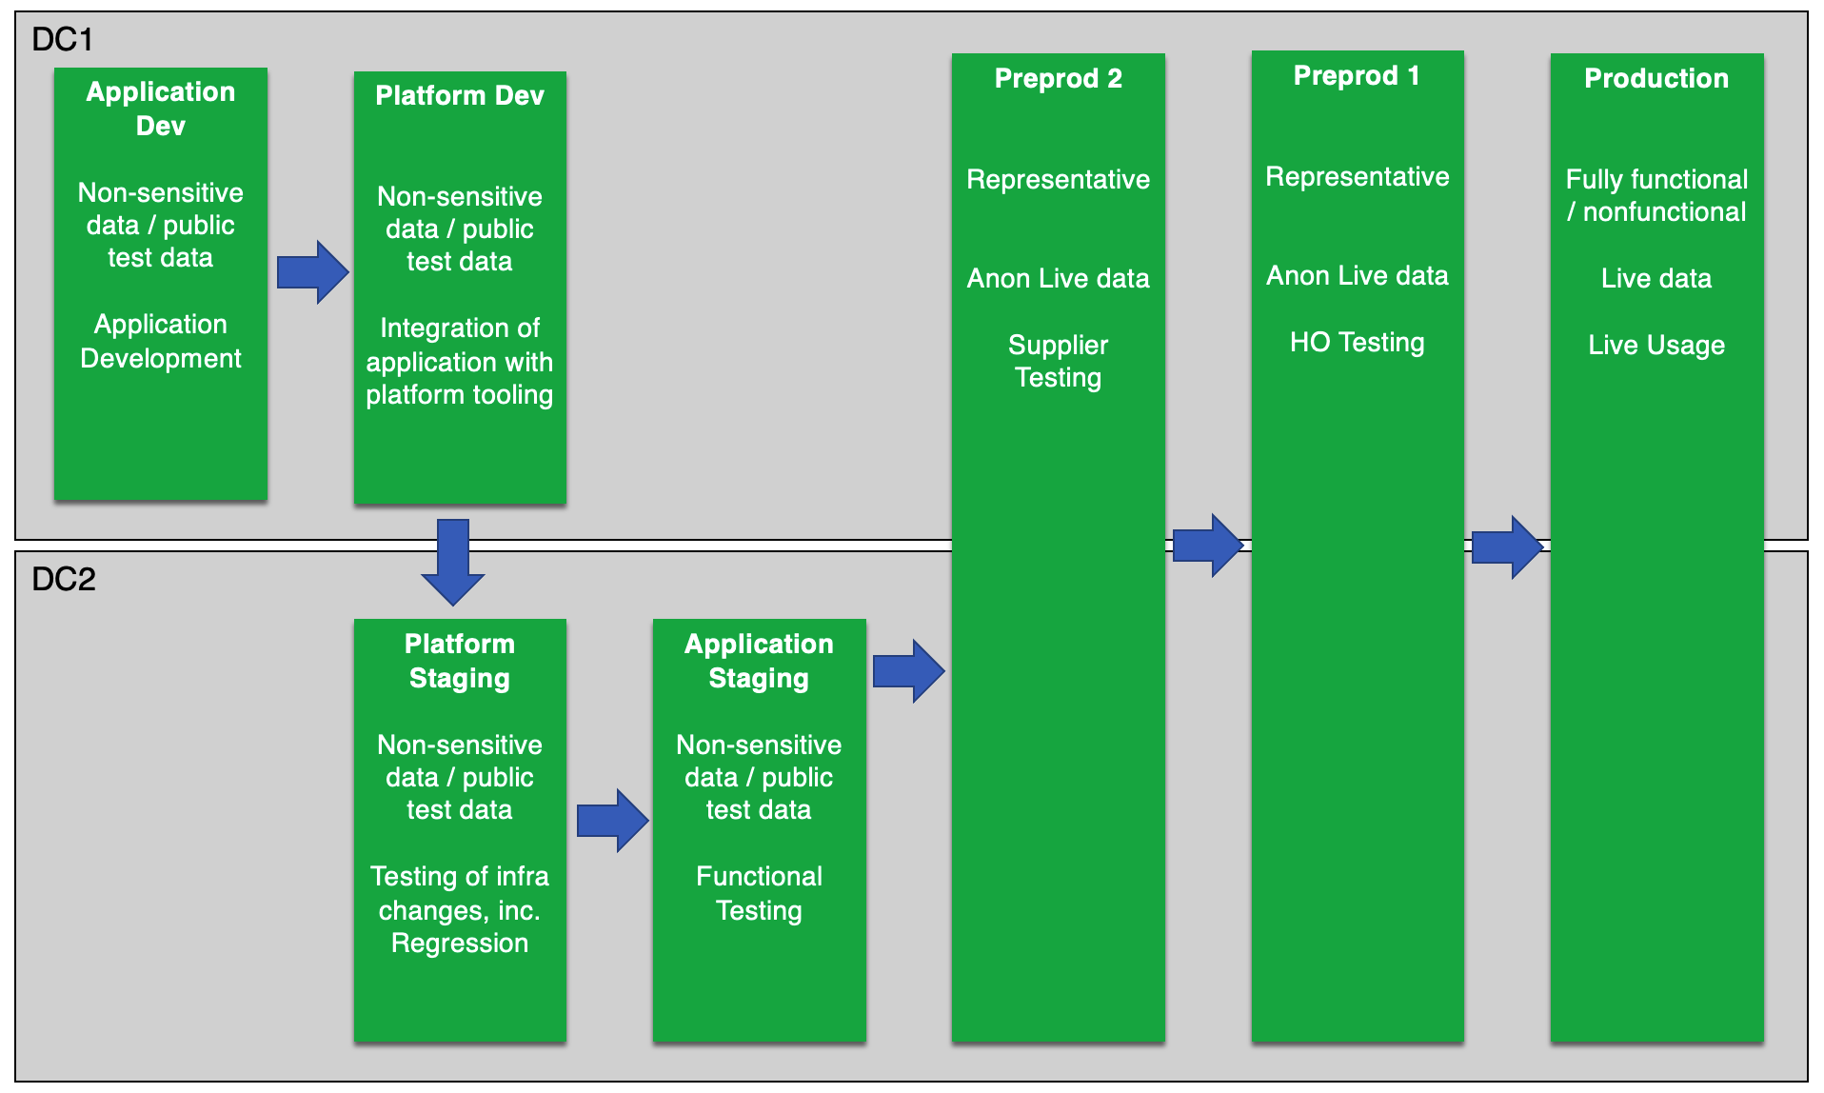

Figure 13 – Environments Summary and Path to Production

Figure 13 depicts the typical path to production for an application change, and the testing to be performed in each environment. Releasing changes through all environments in this manner is important for having consistency of environments, although it is anticipated that some changes will:

* Bypass an environment e.g. infrastructure changes where the affected tool isn’t deployed in the development environments.
* Release in a different environment order e.g. an emergency fix releasing to production via some but not all of the environments to balance testing with speed of release, and then being deployed later to the remaining environments to restore consistency.

## Systems Management software and Supporting Tools

The systems management and supporting tooling is described in section *5.1.1 - IT Systems Management*.

## Infrastructure Changes

This section describes the major changes to infrastructure identified, in particular relating to the stage 1 transition, and for the stage 3 build-out to support face matching capability.

### Transition Architecture – Support Sites

IBM will use two established sites – Hursley & Leicester - to deliver the project and provide live support services including security operations centre (SOC) capability. Hursley is already a List X site and is used to support several Home Office critical national infrastructure systems. Our Leicester location has been used to support several sensitive law enforcement programmes and effort/cost included in the plan to extend this to List X status.

These sites will need to have remote desktop connectivity establishing to the Matcher platform in Crown Hosting. The network changes to enable this are described in section *3.6 - Network Architecture*. Once the underlying networking is in place, we propose to follow the same remote desktop approach as is currently in place, using Fujitsu thin client devices to provide the quickest transition approach and to reduce risk. This solution is based on:

* Fujitsu FUTRO S540 – Thin clients – for Hursley (including the SOC team) and Leicester
* Scout Enterprise Server (manages thin client devices) & Scout Elias eLux RP (manages the thin client images)

For exchange of software packages with Aware, we will continue the use of secure FTP based on the SendSafely which provides an end-to-end encrypted service.

### Transition Architecture – Witness Services

The witness services to prevent split-brain problem for clusters in certain failure scenarios require a new hosting solution. These are currently hosted in incumbent supplier data-centres which will no longer be available.

As described in Architecture Decision 3, we propose the use of the data centres that are already used for Home Office secure services (Portsmouth and Hursley) to host the witness services.

Two witness servers per site (four in total) will be migrated (‘lift and shift’) from the existing data centres. These servers host virtual machines using Hyper-V to provide the following witness services:

* Idemia Witness
* NetApp MetroCluster Tiebreaker
* Microsoft SQL Server Witness Fileshare

### Additional Crown Hosting Capacity

For the introduction of the face MES in stage 3, additional processing capacity is required. Additional servers will be procured and installed into the two crown hosting data centres.

The table and diagram illustrate the overall change to the infrastructure footprint, using the figures from DR040 BMPS Environment Plan.docx section 4 as the baseline.

.

|  |  |  |  |  |  |
| --- | --- | --- | --- | --- | --- |
| Env | Type | DC1 | | DC2 | Total |
| Prod | Existing | 68 | | 68 | 136 |
| Prod | Additional MES | 26 | | 26 | 52 |
| Prod | Additional Aware | 4 | | 4 | 8 |
|  | **Sub-Total** | **98** | | **98** | **196** |
| PP2 | Existing | 34 | | 34 | 68 |
| PP2 | Additional MES | 13 | | 13 | 26 |
| PP2 | Additional Aware | 2 | | 2 | 4 |
|  | **Sub-Total** | **49** | | **49** | **98** |
| PP1 | Existing | 34 | | 34 | 68 |
| PP1 | Additional MES | 13 | | 13 | 26 |
| PP1 | Additional Aware | 2 | | 2 | 4 |
|  | **Sub-Total** | **49** | | **49** | **98** |
| Stg/Dev | Existing | 13 | | 13 | 26 |
| Stg/Dev | Additional MES | 0 | | 0 | 0 |
| Stg/Dev | Additional Aware | 0 | | 0 | 0 |
|  |  |  | |  |  |
|  | **Total Existing** | | 298 | | |
|  | **Total Additional MES** | | 104 | | |
|  | **Total Additional Aware** | | 16 | | |

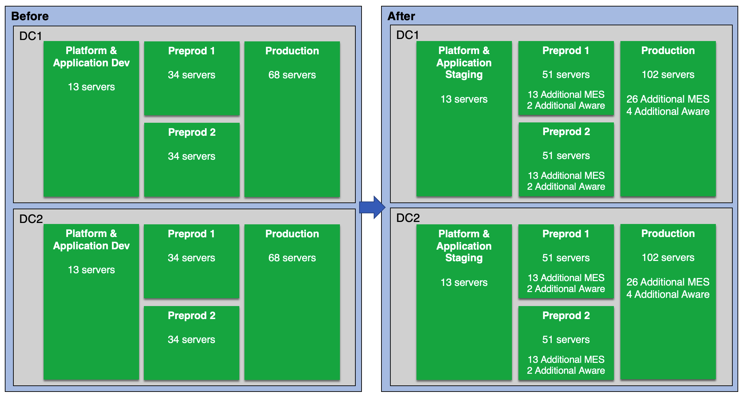

Figure 13 - Additional Servers for Face Matching

The majority of additional servers are required for face MES processing. The figure provided in the ITT for additional servers – 103 – has been used, although we have increased this to 104, to allow it to be fully divisible into ‘whole’ servers in each environment:

* half (52) to production and evenly split across the 2 data-centres (26 in each)
* quarter (26) to pre-production 2 and evenly split across the 2 data-centres (13 in each)
* quarter (26) to pre-production 1 and evenly split across the 2 data-centres (13 in each)
* no increased capacity allocated to development / staging. It has been assumed that the existing MES deployment is sufficient given that this is used for development / functional test activity, not for processing significant volumes.

Additional Aware BioSP servers have been included in the table above to provide capacity to handle increased numbers of requests from Central systems for face processing in stages 3-5. As part of project delivery we will put in place a performance and capacity model (or transition and enhance an existing model), to project the increased Aware BioSP server footprint based on the non-functional requirements, performance statistics from the existing system and results from performance testing.

In advance of this information, the numbers in the table above have used the number of annual requests from *Schedule 2.1 Services Description v1.0 FINAL- Annex D* to project the likely load and associated increase in servers. This shows that face workloads need to be able to process approximately half the number of transactions per year / per day to the combined fingerprint volumes that the system is currently sized for.

On this basis we are projecting an increase of 50% of the number of Aware BioSP servers, which is shown in the table above. This will be reviewed, alongside the projected number of MES servers as part of the project delivery.

| Service | Annual Requests | Peak Day |
| --- | --- | --- |
| Stage 1 & 2 - LE Fingerprint | 148,129,000 | 730,499 |
| Stage 3 - Immigration Fingerprint | 48,755,000 | 240,436 |
| Stage 3 - Immigration Face | 29,080,000 | 143,423 |
| Stage 4 - HMPO/FBIS/EUSS/ | 58,882,000 | 290,377 |
| Stage 5 - LE Face | 14,700,000 | 109,680 |
| Total | **299,546,000** | **1,514,415** |
| Fingerprint total | 196,884,000 | 970,935 |
| Face total | 102,662,000 | 543,480 |
| Fingerprint proportion | 66% | 64% |
| Face proportion | 34% | 36% |

At this time we have not projected any additional servers for management capabilities e.g. Microsoft Service Center, SAN Management, etc. based on the assumption that these servers and the physical hosts that they run on are not fully loaded and will have capacity available, but this also will be reviewed as part of project delivery and performance/capacity modelling.

For the physical servers, we currently plan to use newer servers such as the RX2530 M6, as the M4 end of service life data is understood to be 31 December 2024. We will review this with the MES software supplier to ensure compatibility with their software and the existing MES deployments.

## Network Architecture

The network architecture focusses on the network links between sites and the changes that are required as part of stage 1.

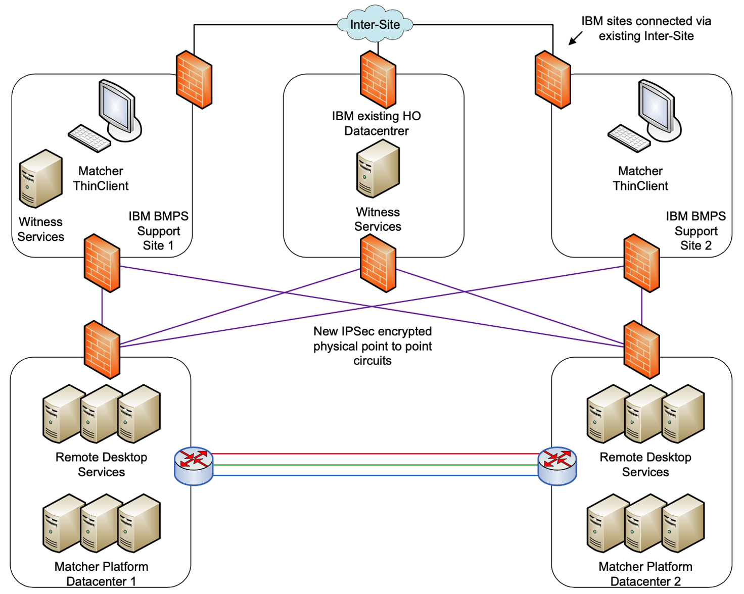

Figure 14 – Network Architecture

There are five physical sites to be connected:

* Matcher data centre 1
* Matcher data centre 2
* IBM support site 1 (Hursley) which also acts as a witness service site
* IBM support site 2 (Leicester)
* 2nd witness site

The sites will be connected in a full mesh topology. There is existing connectivity:

* between the two support sites; and
* between the two Matcher Platform data centres.

All sites will be provisioned with dual point to point (p2p) circuits to provide resiliency and flexibility. Diverse physical routing of the circuits will be requested from the supplier to avoid any common points along the length of each circuit, this will remove the possibility of an outage (either planned or unplanned) taking out administrative access and reduces the possibility of ‘state’ on network devices requiring applications to restart following a circuit failure.

A new resilient pair of Juniper SRX devices will be delivered into each of the IBM support and Witness sites.  For the connections from the support and Witness sites to the Crown Datacentres, we propose to deploy new Juniper SRX devices at each Crown datacentre to create secure site-to-site IPsec VPN tunnels over each point-to-point circuit. This de-risks the connectivity cutover by using separate devices.

Each site will have a bandwidth of 100Mbps. QoS will be used to prioritise traffic to the Matcher platform datacentres.

The circuits and network devices required to implement these connections are summarised in the table:

| Item | Description | Count |
| --- | --- | --- |
| P2P circuits Hursley to Crown DC1 and DC2 | Point to point connection from Hursley to each Crown data centre for site-to-site IPSec VPN | 2 |
| P2P circuits Leicester to Crown DC1 and DC2 | Point to point connection from Leicester to each Crown data centre for site-to-site IPSec VPN | 2 |
| P2P circuits Portsmouth to Crown DC1 and DC2 | Point to point connection from Portsmouth to each Crown data centre for site-to-site IPSec VPN | 2 |
| Juniper SRX 345 | 2 firewalls at each site for resilient connection | 10 |
| Fortinet - Fortiswitch 124F | 2 switches at each site for resilient connection | 10 |
| Fortinet - Fortiswitch 124F | Switches for support sites (Hursley and Leicester) to provide connections for thin client devices | 8 |

### Interim networking solution

Section 3.6 describes the planned ‘end-state’ connectivity. This will be implemented once all network circuits and hardware are available. Ahead of this there may be a need to implement an interim solution to establish connections from support sites for Service Commencement Date.

The shortest lead time for circuit delivery from Crown Hosting locations is to Portsmouth, as this location is ‘on-net’ with the intended carrier Lumen. As Portsmouth is only intended as a witness site, the support sites will need to connect via Portsmouth to Crown Hosting. This connection is proposed to use:

* Existing point to point connection from Hursley to Portsmouth used by the Home Office Semaphore project
* Leicester? (does this use the IBM inter-site to get to Hursley? Is this secure enough?)

## Network Separation

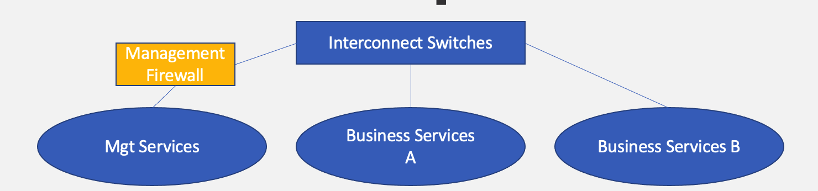

Figure 15 - Additional Solution – Firewall Separation

One of the additional services for stage 1 is the introduction of a firewall capability to separate the management and business data networks. This is to mitigate a security risk with the existing separation using ACLs on network switches.

To deliver this, firewalls will be implemented in each site to provide this capability. A pair of firewalls will be implemented in each site for resilience to meet the availability requirements. It is assumed that devices are needed in PP2 but not PP1, as the management services are only hosted in PP2. Additionally a single device is provisioned for dev/test activities in advance of this.

Based on the number of environments, the table shows the distribution of firewalls, leading to 9 new devices in total.

| Environment | DC1 | DC2 | Total |
| --- | --- | --- | --- |
| Production | 2 | 2 | 4 |
| Pre-production 1 |  |  |  |
| Pre-production 2 | 2 | 2 | 4 |
| Platform staging | 1 |  | 1 |
| Total | **5** | **4** | **9** |

Based on the materials shared in DR043 Firewall Separation of Management and Data Networks v1.1.docx section 6.1, the stated traffic management volumes that will transit the new firewalls are:

* Pre-production:18082.53 Mbps
* Production: 31680.34 Mbps

These figures appear to be very high – they will be used for the purposes of the bid response to size the devices, and then re-examined during the delivery phase.

Once the firewall devices are installed, the main build activity is to analyse the existing rules to identify those relating to business / management traffic, move the identified rules to the new firewalls and test that all routes work correctly.

A technology selection is required for the new firewalls, with the main options being Cisco and Fortigate. Our recommendation is to use Fortigate as they are lower cost, and have more features including longer log storage. Our teams are familiar working with both brands, with Fortigate also being viewed as more flexible to work with.

The DR043 document highlights the need to move servers from management to business VLANs to support the separation.

* Aware BioSP database. Reviewing the DR240-08 SQL Server 2016 LLD, this is described as a separate database instance from the other management servers. This is corroborated by the hardware asset register which shows a separate SQL Server VM for Aware. As such it is assumed there is a small amount of effort to move this VM to a business VLAN, but no need to provision an additional VM / SQL server instance
* The Audit database which is currently on the management SQL Server instance needs to be moved to the business zone. This will need a new two node (per environment) cluster to host this database instance. There is assumed to be sufficient capacity to create these additional virtual machines.
  + Production: two-node cluster SQL Server 2016 Enterprise and Windows Server 2016 Standard; and additional base software agents
  + Pre-production 2: two-node cluster SQL Server 2016 Enterprise and Windows Server 2016 Standard; and additional base software agents
  + Pre-production 1: it is understood that the management tooling is installed only in PP2 to support both PP1 so not required in this environment
  + Staging / Development: there is no requirement for separation in these environments so the database will not be separated.

The additional audit database VMs will require the additional software licences to be added to the bill of materials.

| Software Licences | Count |
| --- | --- |
| Microsoft Windows Server 2016 Standard Edition | 4 |
| Microsoft SQL Server 2016 Enterprise | 4 |
| Microsoft Remote Desktop Services | 4 |
| Athene Syncsort for Windows VM | 4 |
| McAfee Endpoint Security for Windows | 4 |
| LogRhythm System Monitor Pro Agent Licence | 4 |

## Performance Engineering Modelling Approach

Performance and resilience of the solution are ingrained in IBM’s delivery approach and are considered at all stages in the delivery lifecycle. We use an IBM global method - Performance Engineering and Management Method (PEMM) - whereby an engineering-based approach is taken with performance planning and performance testing. Using PEMM, parametric models are built and performance and capacity budgets are provided to design and development teams to ensure efficient and performant solutions are designed, built and tested to work as specified.

Our staff plan includes a performance architect to receive and review the existing performance and capacity models, and to determine whether to continue to extend them, or alternatively to migrate the base data into IBM’s own ‘RUMPUS’ (Re-Usable Model of the Performance & Utilisation of Systems) performance model which has been proven and refined over many engagements. We also include performance test expertise throughout the build and test phases, through to stage. This testing is used to iteratively refine the performance model to build confidence in the solution’s ability to meet the performance and capacity requirements based on real-world data.

We recognise the importance of robust performance engineering in the success of the HOB Matcher service. Matcher has a combination of high volumes, large message sizes and low latency. These challenges make the performance modelling and performance-oriented design key elements in ensuring non-functional requirements and SLAs are met.

The use of modelling gives many benefits, some of these are listed below:

| Lifecycle Stage | Benefits |
| --- | --- |
| Transition | Handover and review of existing performance and capacity models for stage 1, which are expected to cover:   * Estimation of system resources needed to support the business workload (to aid architecture & Infrastructure design). * Gives a better view of hardware procurement needs and when that hardware is required in advance of committing to additional hardware procurement for stage 3. * Indicates technical performance risk during the design phase so problems can be resolved at that time ahead of delivery. * Examination of the NFR profile. |
| Build | Validation of design decisions based on information from code traces or simple tests (e.g. stopwatch testing of single transactions). |
| Testing | Validation of test results (do they make sense) and then the prediction of likely behaviour in production.  Calibration of the model to improve predictive accuracy. |
| Live running (production) | Prediction and management of performance and capacity as the workload grows (e.g. organic growth).  “What if” planning for future change. |

The performance engineering approach considers both performance and capacity to enable the overall solution to meet non-functional requirements.

We will describe our use of these engineering approaches in the sections that follow, focussed on performance, capacity and bandwidth in turn.

## Performance

This section gives a high-level description of how we will establish a performance baseline and then maintain and extend this through stages 2 to 5 to identify changes and enhancements required to the solution to meet the required processing volumes and transaction response times. For ‘performance’ we are focussing on the ability of the solution to meet the desired response times whilst operating at the average and peak system load. Considerations of storage and network will be covered in the capacity and bandwidth sections respectively.

### Performance Engineering

Our performance engineering approach is:

1. Start with a static analysis performance model based on non-functional requirements, assumptions and experience;
2. Refine the model by working with vendors of software and hardware to identify existing benchmarks for comparison and also obtain vendor sizing estimates;
3. Provide budgets and targets to design and development teams;
4. Refine the model by designing solution specific benchmark tests (early performance tests) of specific components and feeding the results into the model; and
5. Refine the model by running full system E2E benchmarks and feeding the results into the model.

This approach is illustrated in Figure 17 below.

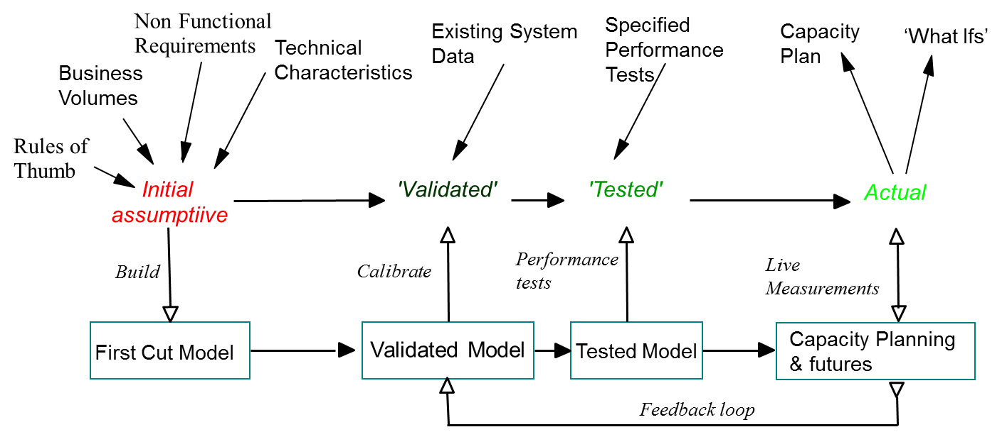

Figure 17 – Performance model life cycle

### Performance requirements

We understand that the required response times have been segmented into a range of response time categories, from half a second to almost 6 hours.

|  |  |
| --- | --- |
| Response Time Category | Matcher Subsystem Response Time Target (seconds) |
| 1 | 0.5 |
| 2 | 2 |
| 3 | 15 |
| 4 | 50 |
| 5 | 120 |
| 6 | 260 |
| 7 | 500 |
| 8 | 1100 |
| 9 | 3300 |
| 10 | 21400 |

The important factor for a performance model and overall system performance is to meet these response times when the system is under the expected load. The table below summarises the overall system transaction volumes based on the 2019 figures, and with a 3% per annum figure to show 2024 projections.

|  |  |  |  |  |  |
| --- | --- | --- | --- | --- | --- |
| 2019 basis | | | | | |
| Stage | **Annual Volume** | **Peak Day** | **Peak Second** | **Average Day** | **Average Second** |
| 1 & 2 | 148,129,000 | 30,499 | 55 | 405,833 | 9.4 |
| 3 Fingerprint | 48,755,000 | 240,436 | 18 | 133,575 | 3.1 |
| 3 Face | 29,080,000 | 143,423 | 11 | 79,679 | 1.8 |
| 4 | 58,882,000 | 290,377 | 22 | 161,321 | 3.7 |
| 5 | 14,700,000 | 109,680 | 3 | 40,011 | 0.9 |
| Total | **299,546,000** | **1,514,415** | **108** | **820,419** | **19.0** |

|  |  |  |  |  |  |
| --- | --- | --- | --- | --- | --- |
| 2024 projected | | | | | |
| Stage | **Annual Volume** | **Peak Day** | **Peak Second** | **Average Day** | **Average Second** |
| 1 & 2 | 171,722,109 | 846,849 | 64 | 470,471 | 10.9 |
| 3 Fingerprint | 56,520,407 | 278,731 | 21 | 154,850 | 3.6 |
| 3 Face | 33,711,690 | 166,267 | 12 | 92,370 | 2.1 |
| 4 | 68,260,376 | 336,627 | 25 | 187,015 | 4.3 |
| 5 | 17,041,329 | 127,149 | 3 | 46,384 | 1.1 |
| Total | **347,255,912** | **1,755,622** | **126** | **951,091** | **22.0** |

### Performance Model

As our engagement is expected to begin with NFR testing of the stage 1 solution, we anticipate a handover of the existing performance model which has been refined by the previous performance testing for stage 1 system load. As such, we do not plan to create a theoretical model in this solution outline stage, as it does not have access to the same depth of real-world data as the current project delivery. After handover of the existing model, we will perform a due diligence review and decide whether to continue to extend it, or to migrate the data to the IBM RUMPUS tool. The benefit of RUMPUS is that it provides a structured way to construct the model, has been refined over many complex project engagements, and is based on a standard tool (Microsoft Excel).

We will then continue to refine the performance model using the performance engineering methods described in the previous sections including incorporating performance metrics from real-world usage and controlled performance testing. The model updates will include phased increases in system processing requests for each stage in turn, as well as the increased processing capacity to be provisioned for stage 3 to meet the combined demands of all traffic up to stage 5.

We will overlay on this model the increased processing load for each phase of data migration. This will be modelled based on running the data migration both full-time and only in times of low system usage, to inform the trade-offs to be made about how quickly the data migration can be performed, whilst not impacting live system requests. Each data centre is sized to be able to run 100% of the load (for DR scenarios), which implies in normal circumstances that there is only a maximum of 50% usage per data-center, leaving the remainder available for data migration traffic, giving early confidence that this is sufficient. This will be assessed using the performance model and testing during performance testing.

Using ongoing modelling and testing iterations, we will:

* identify components that are particularly at risk of performance issues and potential bottlenecks; and
* work with the application and infrastructure teams to build mitigations to the risks.

To meet the non-functional requirements for performance and capacity the performance model will be used to predict the sizes for the node count, compute and memory requirements. This will be augmented by the capacity and bandwidth models for storage capacity, IOPS, and WAN latency/bandwidth

## Capacity

Capacity Planning is an integral part of the IBM Performance Engineering & Management Method (PEMM) and is a set of tasks many of which are performed iteratively throughout the lifecycle in collaboration with the operational staff who will be responsible for running the service once live. Capacity modelling is a key element of this process.

Capacity can take several meanings in the context of system performance, all of which need to be modelled and planned:

* system processing capacity (CPU, memory, IO)
* storage capacity (disk / SAN / backup)
* network capacity (bandwidth)

### Processing capacity

System processing capacity will be projected using the performance model described in the previous section as the basis. Traffic growth projections will be derived from observed trends from the real system activity, and informed by business knowledge e.g.:

* of seasonal variations and spikes in usage
* of events that may lead to step changes in usage such as legislative change
* increments in usage such as stages 2-5 as new user-bases are on-boarded
* ad-hoc events such as data migrations

We will use the existing Athene capacity management tooling to provide real system insight into current peaks in usage and the impact on response times, to make predictions on growth trends towards thresholds, and to give insight to where in the system capacity problems are manifesting.

### Storage capacity

A spreadsheet-based storage capacity model will be used. This will be based on the volumetric information on gallery sizes that has been shared for the number of data objects to stored, and with average storage for each type of data object based on information from software vendors and from assessment of the observed system storage volumes.

Separate models are anticipated for MES storage and MSB storage, to cater for the different resulting data entities to be stored. Rather than create a theoretical model at this stage in the bid, given the maturity of the system build expected at transition, we anticipate transition and extension of an existing model, or creating a new model if required in the early stages of the transition phase.

As with processing capacity we will use the existing Athene capacity management tooling (with the NetApp integration module) to provide system insight into growth trends across the system and proactive notification of trending towards a threshold.

### Network capacity

A spreadsheet-based network capacity model (such as RUMPUS) will be used. This will use the main inputs from the existing performance model, and assign network sizing to each of the major transaction request and responses, which is then used to anticipate the overall load on the network and the impact of traffic growth.

As with processing / storage we will use the existing Athene capacity management tooling (with the SolarWinds integration module) to provide system insight into growth trends across the system and proactive notification of trending towards a threshold.

### Capacity provisioning activities

Using the performance / capacity model and observed growth trends, we will set appropriate thresholds to trigger activities to provision more capacity. This could for example include provisioning additional servers into load-balanced clusters, or adding more disks to SAN storage. Before these measures are taken, we will seek to identify ways to reduce capacity consumption wherever possible, such as ensuring that filesystem housekeeping is operating correctly, and working with MSB and MES software vendors to tune their applications for most efficient operation.

Where provisioning measures are being taken, we will monitor critical thresholds beyond which more significant expansion activities are needed. This is for example reaching capacity in the existing server racks, or SAN array. These critical thresholds will be part of long-range monitoring so that there is sufficient time to implement the required expansion.

These activities will be managed via the overall change process, so that appropriate testing can be undertaken, and so that the changes can be planned to be delivered without disruption to service.

## Bandwidth and I/O

There are 6 network interactions to consider for the HOB Matcher system as described in the table:

| Network Interaction | Scope | Description |
| --- | --- | --- |
| Request messages and responses | Inter-site | Connections from the HOB Central systems over the HO WAN will be provided by the Authority. The bandwidth of these connections needs to be sufficient for the processing of Category 1 and 2 latency request types. |
| MES services | Inter-site & Local | MES is active/active, so connections can be either within the same data-centre, or can cross from one data-centre to the other. |
| MSP traffic | Local | Local networks refer to server to server traffic within the same data centre. The SAN and local replication traffic also falls into this group. |
| Data Centre to Data Centre | Inter-site | Inter-site networks carry the following types of traffic:  Application to application; Database replication; Database actions; Cluster data; and Storage replication. |
| Management data | Support Sites | Management networks carry data to allow the remote management of the HOB Matcher service from the service provider’s locations. |
| Witness Site | Inter-site | New point-to-point connections to carry data relating to the witness services and their management. |

As with the other performance models, we anticipate reviewing the existing models as part of transition and determining whether to continue to use this, or to move to using the IBM RUMPUS tool which includes sections for estimating bandwidth utilisation. The E2E time for a given use case (transaction flow) can also be estimated using the RUMPUS tool.

We will continue to work on using and extending the bandwidth model as part of transition and beyond. work with the Authority to refine the model as part of transition when we have access to more detailed information from real system operation.

Modelling will be used to facilitate estimation of:

1. Network bandwidth and utilisation for key elements or the solution. This is especially important for networks which cross a data centre boundary. This bandwidth model will also be used to support capacity planning throughout the service period; and
2. Network latency for the data centre to data centre traffic. To support the RTO and RPO availability requirements, there is a need to understand the effect of that the geographic distance will have on data exchange between the sites. As the sites are 100km apart, the speed of light in the fibre connections will be a controlling factor here. A network latency model also informs the time budgets allocated to the MSP solution, as time used in the network forms part of the Authority category-based latency NFRs.
3. Disk-based I/O for the solution. The performance model will include for the main use-cases the points at which disk reads and writes occur and combined with the typical sizing of data entities will be used to project the I/O usage, which will be calibrated based on real-world observations.

## Tech Refresh

As described in Architecture Decision 4 and discussed during negotiations the following high level approach is adopted for tech refresh:

* Software to be kept in support to ensure that security patching is always in place
* Hardware to be kept in support for security-enforcing and perimeter devices
* Other hardware (e.g. server infrastructure) is not included in the current scope and will be introduced as a CR at the point it is agreed to be necessary.

### Software Refresh

The following software refresh components and dates have been identified:

| Component | Version | Std Support End | Extended Support End |
| --- | --- | --- | --- |
| Red Hat Enterprise Linux | 7.9 | 5 Aug 2019 | June 2026[9] |
| Windows Server | 2016 | 11 Jan 2022 | 12 Jan 2027 |
| Microsoft Hyper-V | 2016 |
| Windows Datacentre | 2016 |
| Microsoft SQL Server | 2016 | 11 Jan 2022 | 12 Jan 2027 |
| Microsoft System Center | 2016 | 11 Jan 2022 | 12 Jan 2027 |

The high-level approach to the software refresh is as follows:

1. Tech refresh will be performed between the later rollout phases, and in advance of the June 2026 RHEL support end-date
2. The target OS versions will be RHEL 9 and Windows Server 2022 and it is assumed that these will be supported by the MSB and Matcher Engine software at the time of upgrade. Specifically IDEMIA will have tested and warranted RHEL 9 as supported in advance of the upgrades / tech refresh starting.
3. Target software versions will be SQL Server 2022 and Microsoft System Center 2022
4. The software refresh will be planned to reuse existing hardware such that there is no significant ‘extra-capacity’ i.e. old and new hardware live at the same time which might have licensing implications.
5. The new face matching engine will be built using newer software versions (RHEL 9) to avoid adding to the refresh scope and to establish the RHEL 9 deployment and management in advance of tech refresh.
6. Refresh will be performed to avoid downtime e.g. using rolling upgrades of each node in a cluster in turn, or using a blue / green deployment approach to direct all traffic to site 1 so that site 2 components can be upgraded, then switching to site 2 and upgrading site 1.
7. Refresh will be grouped into logical subsystems to divide the refresh into manageable groups. These are likely to consist of:
   1. Aware,
   2. Idemia MES
   3. NEC MES
   4. MS System Centre
   5. groups of remaining supporting services (e.g. Athene, LogRhythm etc).
8. Scripted upgrades for each logical subsystem would be:
   1. prepared and tested in the PDE and PSE environments, including creating a draft technical implementation plan (TIP).
   2. trialled in PP2 using the TIP including fixing any issues encountered in a representative environment and refining the TIP.
   3. released into PP1 as a dress rehearsal ahead of the production release – including taking timings of all activities to inform the final production deployment planning.
   4. released into Production soon after the PP1 release (e.g. PP1 during the week, Production at the weekend) to minimise the period of time where there is a different software level between production and pre-production environments.

### Hardware Refresh

The following hardware refresh component dates have been identified:

| Current | End of Life Date | Replacement | Notes |
| --- | --- | --- | --- |
| Cisco ASA 5525 | Not announced (see notes) |  | Believe these are Cisco ASA 5525-X model that hasn't had an end of support announcement |
| Cisco ASR 1002-HX | Not announced |  |  |
| Cisco Nexus 3048TP | 31-Aug-2025 | Nexus 9348GC-FXP |  |
| Cisco Nexus 9K Switch ToR (top of rack) | Not announced (1 model at 28-Feb-2025) |  | 1 device serial number has an announced refresh date. |
| Cisco Nexus 9300 |  |
| Catalyst 2960-XR Switch | 31-Oct-2027 |  |  |
| Cisco Catalyst 2960-B | 31-Oct-2027 | C9200-48T |  |
| Cisco Catalyst 2960-X | 31-Oct-2027 | C9200-48T |  |
| Catalyst 2960-XR | 31-Oct-2027 | C9200L-48T-4X |  |
| FMC1000 | 31-Jul-2024 | Cisco FMC-1600 |  |
| F5 Big IP i2800 | Not announced |  |  |
| GigaVUE-HC1 | Not announced |  |  |
| Juniper SRX-300 | Not announced |  | There are references to specific SKU's. Confirmation needed of the current ones however we believe end of support date not yet announced |
| NetApp DS224C Shelf | Not announced |  |  |
| NetApp DS460C Shelf | Not announced |  |  |
| NetApp Filer AFF A700 | Not announced |  |  |
| NetApp Filer FAS 2620 | 31-May-2024 | * Refresh to be performed by incumbent prior to Service Commencement Date | |

The approach for refresh of each hardware device type with an identified end-of-life date and replacement device is as follows:

#### Switches (All Cisco devices in the list)

As these are Cisco switches replacing the devices (as they are the same devices) the process is fairly straight-forward.

* During the build process for the new device, the configuration of the existing device will be backed up.
* Minor modifications will be required to the interface layout.
* The configuration will then be restored to the new device.
* The process for the physical swap out of each device is to take an audit of the current cabling, turn off and remove the existing device, rack the new device and replace the cabling and power on.
* This process is repeated for each individual switch.

#### Firewall console (FMC)

* Deploy the new FMC with new management IP addressing
* Patch and update the new FMC to the same level as the old FMC, including running software version
* Create a full back-up on the old FMC (including configuration, events and Threat Intelligence Director if in use)
* Copy the backup file from the old FMC to the new FMC
* Unregister the old FMC from the Cisco Smart Software Manager
* Disconnect the old FMC from the network
* Register the new FMC with the Cisco Smart Software Manager,
* Verify registration of the firewall devices to the new FMC to complete the migration.

#### Storage (NetApp)

Refresh to be performed by incumbent prior to Service Commencement Date

# Security

In this section we describe our approach to maintaining the security of the HOB Matcher solution. This encompasses:

* our teams and ways of working, including the transition activity and secure development lifecycle
* our security operations centre (SOC) capability
* our understanding of the core security features of the HOB Matcher solution and how we will maintain these
* the optional audit solution that has been requested as part of the ITT

## Secure ways of working

Our project and support team staff will be sourced from our secure delivery centres in Hursley and Leicester. They have a long experience of working on secure Home Office programmes for immigration, law enforcement and biometrics including the original IABS delivery and support, Semaphore, NLEDP and several others. We perform regular security awareness briefings, led by our security practice, to ensure that all team-members understand the guidelines from the SAL (security aspects letter), and broader secure working best practices. Security and privacy is a central focus for all IBM staff, not just those in our secure delivery centres. This includes annual cybersecurity training for all employees, including privacy and GDPR.

Hursley is a List X facility and is used to support several Home Office critical national infrastructure systems. All aspects of the physical, procedural and technical security measures in the facility has been certified by GCHQ and undergo re-certification on a regular basis. Our Leicester location has been used to support several sensitive law enforcement programmes and we will undertake the activities to extend this to List X status.

Prior to joining IBM, all personnel undergo personal background checks. In addition, our onboarding process will ensure that all personnel will have as a minimum SC clearance, and where required, NPPV3 or DV. Our clearances are managed by the IBM Government Security Office team.

## Privacy

We understand the sensitivity of the personal information that will need to be processed by the Matcher system and propose to maintain privacy of the individual data subjects by taking the following steps:

* Production data would not be allowed to be used in development or test environments without obtaining explicit approval from the Authority and it would be expected to operate some compensating controls, such as:
  + Anonymising the data using an approved and tested method;
  + Using special “approved” sets of biometric test data that has been certified not to contain personal information;
  + Operating the same level of security controls as would be used for production data, including access controls and audit logging; and
  + Limiting the time to the bare minimum and cleaning the test environment afterwards using an agreed algorithm.
* User awareness training for IBM staff on handling personal information;
* The tiered architecture will help ensure the privacy of the sensitive data;
* System administrators will not be allowed to export any sensitive information; and
* Encryption of sensitive personal information both at rest and in transit.

## Patching

A key security mitigation is keeping systems up to date with patching, across all aspects of the infrastructure including operating systems, middleware, applications and network devices. Our teams will take ownership of the ongoing patching cycle to reliably deliver this.

Routine patches will be applied on a regular cycle e.g. monthly, to provide ongoing compliance, aligning to the release frequency from vendors. We will monitor security advisory notifications and alerts for new patches, highlighting our recommendations to the Authority for those that need to be address via the Emergency Change process for urgent rollout based on their CVSS (Common Vulnerability Scoring System) rating.

Patches will be released through the environments following the standard patch to production as shown in the *Environment View* section (*3.3*). This enables the system to be regression tested post-patch to ensure that the behaviour is unaffected (which can sometimes be the case, especially with encryption related patches) and to maintain a consistency of patching levels across the environments.

Overall patch level compliance across the estate will be monitored with vulnerability scans using the existing Tenable Nessus tooling. This will be reviewed monthly with the Security Working Group. Manual scans will be run on an ad-hoc basis e.g. in the event of a high risk vulnerability being published.

## Removable media handling

Use of removable media will be by exception only, and when required will follow our secure operating procedures. This includes signing-out a secure USB device and performing sheep dip scans before connecting to each new network.

If the data migration uses the offline, physical transfer approach, this will first require an approved media plan which sets out the procedures for secure transport. This may include for example, encryption of the device contents, access pin transmitted separately to the device, transport by security cleared staff, and transport in a locked container.

## Security Event Management / SOC

We will use our existing 24x7 Security Operations Centre (SOC) capability to provide Security Event Management using the existing Matcher LogRhythm SIEM implementation.

SOC analysts will access the LogRhythm console using the same remote desktop solution as project/support staff. Security incidents will be raised for suspected or actual fraudulent acts or a breach in security policy. These will be handled using an agreed incident management process that include “lessons learned” steps where applicable. The security event management tooling will preserve the event logs for forensic analysis where required.

Our security team will maintain and continue to configure the SIEM tooling to detect anomalies, uncover threats and remove false positives.

## PKI and Key Management

The messaging and web interfaces will use digital certificates issued based on the HOB programme root CA. This ensures the trust chain which is valid for example as part of a mutual TLS handshake for calling applications, which will present certificates issued by the same trusted root CA.

Certificates will be checked against a CRL (certificate revocation list) to confirm that they haven’t been revoked, as part of operations that use certificates such as TLS handshake. The CRLs are hosted on web-servers (IIS) in both data-centres.

Our security procedures will include the steps to revoke and reissue a certificate in the event of a key being compromised.

Certificate expiry can be a cause of unexpected system outage, when a certificate (or a root / intermediate signing certificate in its trust chain) reaches its defined expiry date, after which system-to-system calls will fail with an error. We will maintain a register of all certificates, and their expiry dates, with notifications significantly in advance. This will provide us the time to arrange for certificates to be renewed, for the change process to be follow and the change to be proven, well in advance of the expiry date.

## Authentication & Authorisation

There are several areas of authentication / authorisation to be maintained within the HOB Matcher solution.

External system calls into HOB Matcher with be authenticated at a boundary device in the DMZ zone with mutual TLS using certificates as described in the previous section. The use of mutual TLS ensures that the transmitted data is encrypted in transit, and that both the caller and receiver trust each other. IP address whitelisting will also be applied so that only the HOB central systems are able to connect to the HOB Matcher exposed services.

Within the Matcher Service Bus, Active Directory will be used for authentication and authorisation of project/support user access to BioSP and related tooling such as BAT manager and the data impex tool.

The Microsoft System Center software used to manage the solution/platform will use Microsoft Active Directory for authentication of project/support user access.

## Integrity

Maintaining the integrity of the system, software and the data encompasses a number of aspects and controls:

* Requests from Central systems via the matcher interfaces will be validated against the XML schema for both syntactical correctness and semantic integrity.
* Data migration will use the matcher interfaces and logic, again providing validation of integrity, and also common processing of messages regardless of whether new or migrated.
* Within the system operations, RBAC controls minimise the number of staff able to perform sensitive operations, and comprehensive audit logging and SIEM monitoring of activities provide the tools to identify and alert on any unauthorised changes to data.
* Anti-virus software for malware protection, including regular update of virus definitions
* Regular patching of the environment and emergency release of critical patches as described in *4.3 - Patching*
* Intrusion detection scanning at the network boundary to identify and block malicious inbound requests

## Audit (including additional solution)

There is an addition solution requested to implement a new MES audit search solution.

This is based on an open source search solution to ingest logs from the MES servers, to index these in a search repository and to enable fast searching and dashboarding of this log data.

The designs shared during the ITT process have included both Elasticsearch and OpenSearch as the technology implementation. Both originate from the same source (Elasticsearch), with OpenSearch being an AWS fork of the project. We are able to work with either technology, and propose to undertake an architectural decision with the Authority and Idemia at the start of our engagement to finalise this selection. Our experience has been that for ‘host your own’ solutions Elasticsearch has a significantly bigger user-base, contributor community, support structure and reference implementations whereas OpenSearch is predominantly used by AWS for their managed search service.

We have experience implementing Elasticsearch / LogStash / Kibana (ELK) solutions on a similar basis to that outlined in the Idemia design. We operate ELK based solutions for searching operational log data with several high-criticality public sector clients and this is an effective approach for aggregating and searching detailed log records compared with searching flat log records. If Opensearch is selected we would seek to identify parallels from earlier ELK installations as the basis for the implementation.

In-line with the proposed design, six additional virtual hosts will be added to each of production, pre-production 2 and pre-production 1 to host the search solution components, as well as 2 for development/test purposes. These virtual hosts are expected to be provisioned from existing capacity on the host machines.

| Environment | DC1 | DC2 | Total |
| --- | --- | --- | --- |
| Production | 3 new RHEL virtual hosts | 3 new RHEL virtual hosts | 6 |
| Pre-production 1 | 3 new RHEL virtual hosts | 3 new RHEL virtual hosts | 6 |
| Pre-production 2 | 3 new RHEL virtual hosts | 3 new RHEL virtual hosts | 6 |
| Platform staging/dev | 1 | 1 | 2 |
| Total | **10** | **10** | **20** |

The additional VMs for MES audit will require the additional software licences to be added to the bill of materials.

| Software Licences | Count |
| --- | --- |
| Red Hat Enterprise Linux 7 | 20 |
| Red Hat Ansible | 20 |
| Athene Syncsort | 20 |
| McAfee Endpoint Security for Linux | 20 |
| LogRhythm System Monitor Lite Standard Agent Licence | 20 |
| LogRhythm Collector Licence | 20 |
| Search Repository | 0 – Open Source |
| Search Dashboard | 0 – Open Source |
| Logstash | 0 – Open Source |
| Filebeat | 0 – Open Source |

Note RHEL 7 is planned for this service for speed of delivery reusing existing images and scripting to protect the stage 1 dates, and for consistency with the existing estate. This will be part of the later tech refresh scope.

## Non-Standard Services (NSS)

The requirements shared during the ITT do not include any security-related non-standard services (NSS). If NSS requirements are later identified during delivery, these will be assessed and added to scope via the programme change process.

# Service model

## IT Service Management Solution

### IT Systems Management

In alignment with Architectural Decision 1, our overall approach is to take on the existing technologies, and to leverage these existing assets and investments in order to focus on the delivery of end-user valuable services as soon as viable for stages 1-5. On this basis we anticipate using the existing systems management tooling as described in the table, and using existing skills within our shared service delivery centre to take on the running and usage of these tools.

Following stage 5 delivery, we will assess the potential roadmap and benefits of changes, including move to cloud as described in Architectural Decision 2. This would include an overall review of the systems management approach and whether there are new technologies for consideration that would bring service, delivery or efficiency benefits.

| Purpose | Tool | Comment |
| --- | --- | --- |
| Systems Monitoring | MS Systems Center Operations Manager (SCOM) / SolarWinds | SCOM provides infrastructure monitoring of servers and devices to report health, availability and performance, taking feeds of data from agents on servers, and from network devices via SolarWinds and alerting monitoring staff to issues needing investigation. |
| Configuration Management Database | MS Systems Center Configuration Manager (SCCM) / RedHat Ansible & Satellite | SCCM is used to asset manage the server estate, including application and patch management of Windows servers.  Linux servers will use RedHat Ansible and Satellite for application and patch management |
| Problem, Incident, Change, Asset and Licence Management | MS Systems Center Service Manager (SCSM) | SCSM is used for ITIL service management capabilities including management of incidents, problems, changes, releases, assets and licences. |
| SLA monitoring and reporting | MS Systems Center Service Manager (SCSM) | SCSM is used for SLA monitoring and reporting including producing reports on incidents, problems, changes, releases etc. |
| Security Monitoring | LogRhythm | LogRhythm will monitor across the HOB Matcher solution for security events, configured in line with GPG-13 guidelines. It will be monitored by our SOC team. |
| Performance Monitoring | Athene | Athene will be used to monitor and manage performance and capacity including producing performance reports. |
| Source Code Management | GitLab | GitLab will be used within the HOB Matcher environments to manage infrastructure source code and scripts. Note 3rd party products such as Aware BioSP will host their own source code separately and deliver packaged code for deployment. |
| Defect Management | Jira | Jira will be used to manage defects identified during testing. As agreed during negotiation the IBM Hursley secure Jira will be used. This has security controls and RBAC to support need-to-know requirements, so only authorised users can access this. Existing POISE access into the Hursley site will allow authority users to access Jira, enabling much greater collaboration on testing progress and defect management. |
| Knowledge Sharing | MS Systems Center Service Manager (SCSM) | SCSM in the Crown Hosting environment will be used for sensitive materials that only need to be accessed by our project/support staff via thin-client.  In addition, we will investigate the use of IBM securely-hosted knowledge tooling - in a similar manner as proposed with Jira – to enable wider sharing of documentation and collaboration with the Authority. We currently use a secure Wiki solution based on BookStack. We will review with your security team to gain approval and to review which content can be shared in this manner. |

Systems Management and log analysis tools will be hosted within the ‘Platform Tooling’ zone, separated from the main MSB and MES application component deployments. This zone and tooling is replicated in each of the main environments[10]: production, pre-production 2, pre-production 1, development/staging. This zone is used to hold all of the management tooling including for example the Microsoft System Centre management tooling and the LogRhythm protective monitoring tools. The exception to this are tools accessed in IBM Hursley for wider programme collaboration (beyond our project/support staff with thin-client access) e.g. Jira.

### Remote Support

We will follow a similar approach to remote access from our project/support sites to the existing approach. We will provide thin client devices and reuse the Scout suite deployed in the data centres, extending the existing service as needed. These will be used to provide remote desktop access into the Crown Hosting environments, to provide the quickest transition approach and to reduce risk. This will provide us access to systems and tooling within the Matcher Crown Hosting deployment for deployment, test and support activity including:

* Deployments of MSB, MES and other solution components
* Data Import Export tooling
* Test tooling including BAT manager
* Microsoft System Center management tooling
* Athene performance/capacity tooling

For day-to-day collaboration with Authority staff, and for access to collaboration tooling as agreed during negotiation we anticipate using supplier laptops[11] - these will be used for

* Emailing securely using CJSM to Authority email systems.
* Microsoft Teams meetings (joining as guests to Authority hosted MS Teams meetings)
* Collaboration/defect tracking in Jira (IBM Hursley secure network instance)
* Knowledge management (subject to security review and approval) in BookStack Wiki solution (IBM Hursley secure network instance)

### Promotion Route to Live

The route for promoting changes to live is as shown on Figure 13 in 3.3 - Environment View and repeated here in Figure 18. The arrows show our understanding of the typical sequence of steps for an application change to be promoted through the environments to production. The description of each environment includes the type of data and the type of testing that would typically be performed.



Figure 18 – Path to Production

### Capacity Management

Our proposed approach for capacity management is described in 3.10 - Capacity. The capacity management activities will be managed from various roles within our shared service delivery team, including our monitoring team tracking capacity usage, our service/ops architects planning upgrades to be implemented by our infra/platform dev team, and the overall change rollout managed by our change process analysts.

### Software licence monitoring and management

We will take on the software listed in the ‘BMPS Software Asset Register’ and the monitoring/management of their licences. Our shared service delivery team includes an asset management capability which will be responsible for tracking licence expiry dates and renewing them to keep all software compliant with licencing. We will monitor for situations where software licences are no longer required (e.g. if a particular technology is no longer used in the solution), and manage the termination of these licences.

## ITSM and Security Management Tooling

### Service delivery locations and organisation role structure

Our service will run from our Public Sector secure shared delivery centre that is split between Hursley and Leicester. The shared service delivery (SSD) centre supports secure UK Public Sector projects including Semaphore, MBTP level 2 support and previously IABS for Home Office. The existing shared support capability within Hursley and Leicester will provide BMPS with a proven dependable 24/7 capability. The existing capabilities within the shared support centres include experienced teams across Level 2 and Level 3 support as well as ITIL and Home Office aligned processes for managing: incident; problem; change and release; asset and configuration management; environment management and test capabilities.

Our security operations centre (SOC) capability which will be used for HOB Matcher is also based in our Hursley location. The SOC are an independent team to ensure separation of duties but with a well proven integration over many years on other Home Office engagements including Semaphore, Disclosure and Barring and previously IABS.

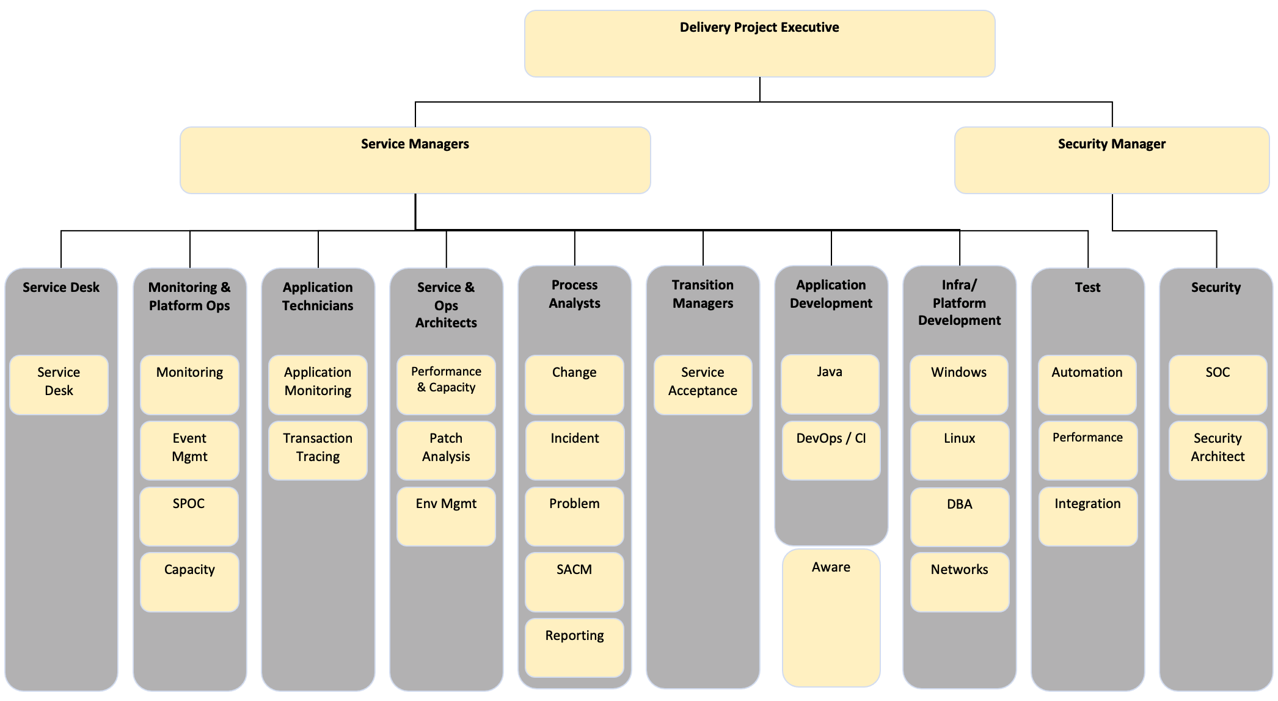

Figure 19 – Shared Service Delivery Centre Organisation

Our service managers will manage interfacing with Authority service management teams and with our key development partner Aware. Service managers will also work collaboratively with the MES suppliers: Idemia and NEC to manage and protect the service, noting that the formal relationship is held between the Authority and these suppliers for aspects such as SLA performance management, commercial relationship etc.

### High level operating manual

Operational instructions and runbooks that have already been prepared by the incumbent for the existing stage 1 HOB Matcher solution are understood to currently be held on the incumbent’s systems and an extract to be provided to the Authority for loading into either SCSM or an IBM hosted wiki platform. The format of this extract will need to be agreed early in the transition period and to be in an agnostic format that can potentially be loaded into a different tool than that currently in use. We will continue to extend this set of instructions/runbooks as part of the build-out of the solution through stages 2 to 5, and informed by ongoing operation of the platform e.g. arising from problem management root cause analysis, and proactive updates from our team.

Our secure service delivery maintains a secure procedures manual for operating procedures including for handling of sensitive materials, removable media handling, data-centre access, etc. This will be extended with any relevant materials for HOB Matcher, for example relating to data migration activities.

### Crown Hosting Operations

In all day-to-day operations and communications with Crown Hosting, IBM shall operate as an agent of the Authority to ensure comprehensive direction and communication for physical installation and in the ongoing operations and management of BMPS. Our support teams will work closely with Crown Hosting to plan any site access requirements and to ensure compliance with associated documentation and access requirements.

Our installation and support teams shall leverage the ‘Intelligent Hands’ service offering from Crown and shall provide supporting documentation (e.g. rack layouts and asset tagging), and process definition (e.g. physical media removal) guidance accordingly. We will work with your security team to agree a secure method for information sharing of documentation with the Intelligent Hands team.

### Support of high priority services and location

Our secure shared delivery (SSD) centre provides 24/7 support for high priority Home Office systems including Semaphore (and previously IABS), with duty technicians working on a shift roster. This service will be extended to provide similar support for the high priority HOB Matcher service.

1. E.g. answer in BMPS Briefing and Clarification Q and As Issued 26 Oct.xls - 37 (CQ9) –

   “… HOB can share a summary of the technical review as follows:

   - The architecture is still valid The architecture is broadly sound in terms of technology approaches.

   - Cloud hosted biometrics matching will not be commercially viable for some years yet at this scale.

   - Defect Handling recommendation - Establish an efficient approach to handling any outstanding defects and tech debt with the new supplier”
2. Schedule 6.1 Implementation Plan v1.0 Final – Section 7.2.2
3. Assumed an MSS user performing queries as requested by business users, based on DR110 Matcher Data Audit.docx
4. DR020 BMPS Transition Status v0.2.xlsx
5. BMPS Volumetric Model embedded in Schedule 2.1 Services Description
6. DR201-01 Data Storage & Data Migration Volumes v0.3.3.docx – annotated with comments for the ITSFT
7. DR340 BMPS MSP Solution Design - Design Model v2.7.docx – section 7.2
8. https://www.fujitsu.com/us/imagesgig5/PRIMERGY-Server%20Support%20Roadmap_EOSL_V4.pdf
9. Based on obtaining ELS for 2 years beyond the end of extended support in June 2024 – as advised during negotiation
10. DR240-03 BMPS Enterprise Management HLD v6.7.docx – Section 2.1
11. During negotiation the Authority expressed this as a preferred way of working for BMPS